|  |  |  |
| --- | --- | --- |
| UCE PHYSICS, PAPER 2 (1987 - 2007 | | |
|  | YEAR |  |
|  | 1987 | <FAQs> |
|  | 1988 | [**FAQs**](FAQs) |
|  | 1989 | [**FAQs**](FAQs) |
|  | 1990 | [**FAQs**](FAQs) |
|  | 1991 | [**FAQs**](FAQs) |
|  | 1992 | [**FAQs**](FAQs) |
|  | 1993 | [**FAQs**](FAQs) |
|  | 1994 | [**FAQs**](FAQs) |
|  | 1995 | [**FAQs**](FAQs) |
|  | 1996 | [**FAQs**](FAQs) |
|  | 1997 | [**FAQs**](FAQs) |
|  | 1998 | [**FAQs**](FAQs) |
|  | 1999 | [**FAQs**](FAQs) |
|  | 2000 | [**FAQs**](FAQs) |
|  | 2001 | [**FAQs**](FAQs) |
|  | 2002 | [**FAQs**](FAQs) |
|  | 2003 | [**FAQs**](FAQs) |
|  | 2004 | [**FAQs**](FAQs) |
|  | 2005 | [**FAQs**](FAQs) |
|  | 2006 | [**FAQs**](FAQs) |
|  | 2007 | [**FAQs**](FAQs) |
|  | 2008 | [**FAQs**](FAQs) |
|  | 2009 | [**FAQs**](FAQs) |
|  | 2010 | [**FAQs**](FAQs) |
|  | 2011 | [**FAQs**](FAQs) |
|  | 2012 | [**FAQs**](FAQs) |
| CLICK HERE TO SEE FREQUENTLY ASKED QUESTIONS. | | |
| Typed and Designed by Swaib Jennerson | swaibj@yahoo.com| | | |

## Go to Index | [E-mail Designer](mailto:kecan44@mynet.com?subject=Comments%20about%20UCE%20Chemistry%201.0) |

|  |  |  |
| --- | --- | --- |
| **535/2**  **PHYSICS**  **PAPER 2** Oct./Nov. 19872 hours |  | UGANDA NATIONAL EXAMINATION BOARD  **Uganda Certificate of Education**  **PHYSICS**  **Paper 2**  **Time: 2 Hours** |

1. (a)

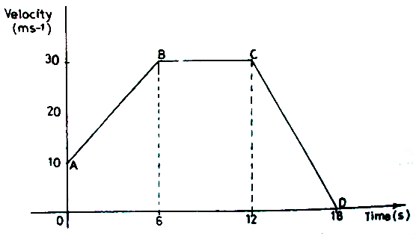

The diagram represents a velocity-time graph of a body in motion

1. Describe the motion of the body
2. Calculate the total distance traveled

(b)

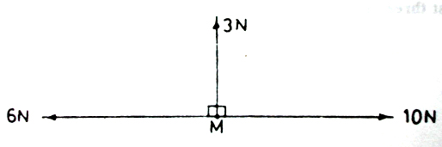

Forces of 3N,6N and 10N act on a body of mass 2kg initially at M. Find the magnitude of the acceleration with which the body moves.

2. (a) (i) Define pressure and state its unit

(ii) Describe an experiment to show that the pressure in a liquid increases with depth. (iii) Find the length of a mercury column in a simple barometer when the barometer is

raised from sea level to a height of 2.5 km given that the average density of air is 1.2 kgm-3 and the density of mercury is 1.36 × 104 kgm-3. Atmospheric pressure at sea level is 76 cm of mercury.

(b) A spring balance reads 2.42 N when a metal cube of side 3.0 cm is suspended in air from the spring balance.

(i) Find the density of the metal.

(ii) What will the spring balance read when the metal is completely submerged in a liquid of density 1200kgm-3.

3. (a) (i) Draw a well labeled diagram to show the essential parts of a d.c motor

(ii) Describe briefly how a d.c motor works

(b) An electric motor of efficiency 90% operates a water pump. The pump raises 0.9kg of water through 10m every second

(i) What is meant by the term efficiency?

(ii) State the energy changes which take place

(iii) Find the electrical power supplied to the motor

4. (a) Use the kinetic theory of matter to explain the following

(i) the valve of a bicycle tyre warms up on pumping

(ii) water on a porous clay pot keeps at a lower temperature than that of the surroundings. (iii) the change of state from solid to liquid

(b) An empty bottle is corked when air inside is at 150C and at standard atmospheric pressure. Calculate the temperature to which the air must be heated for the cork to blow out, if it is able to blow out when the pressure of the air exceeds 4/3 times standard atmospheric pressure. State the assumptions you have made.

5. (a) Describe the composition of the 2311Na atom.

(b) A radioactive nuclide22688X emits an alpha particle and turns into another nuclide Y.

(i) Write a balanced equation to represent this nuclear charge

(ii) How would the nuclide X be affected if a beta particle was emitted instead of an alpha particle?

(c) Describe briefly how x-rays are produced. (Diagram of the x-ray tube is not required)

6. (a) List three differences and three similarities between sound waves and light waves

(b)

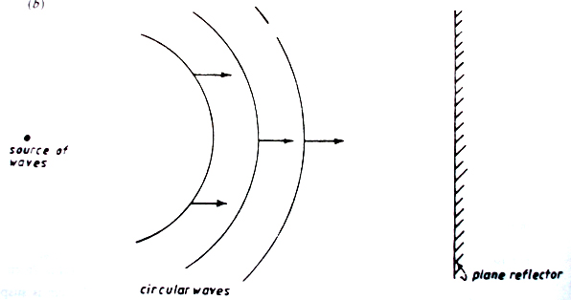

The above diagram shows circular waves propagating towards a plane reflector

1. Draw a diagram to show how the waves will be reflected
2. Calculate the frequency of the waves if their velocity and wavelength are 5.0ms-1 and 0.5m respectively

(c) A man standing midway between two cliffs makes a loud sound. He hears the first echo after 3s. Calculate the distance between the two cliffs if the velocity of sound in air is 330ms-1

7. (a) Describe a simple method of measuring the refractive index of glass in the form of block

(b) (i) Explain, with the aid of a diagram , the term critical angle

(ii) Light of the same wavelength is incident at an angle *i,* on a glass prism. The light is refracted and follows the path shown in the figure below

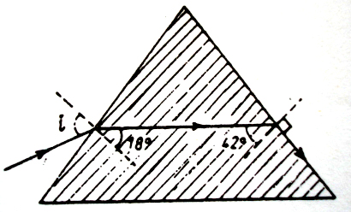

8. (a) Give the advantages of alternating current over direct current in power transmission

(b) Describe, with the aid of a diagram, the construction and action of a transformer.

(c) A transformer is designed to operate at 240V mains supply and deliver 9V. The current drawn from the mains supply is 1.0A. If the efficiency of the transformer of 90%, calculate

(i) the maximum output current

(ii) the power loss

(d) State the possible causes of the power loss in (*c*)(ii) above.

**\*\*\*\*\*\*\*\*\*\***

## Go to Index | [E-mail Designer](mailto:kecan44@mynet.com?subject=Comments%20about%20UCE%20Chemistry%201.0) |

|  |  |  |
| --- | --- | --- |
| **535/2**  **PHYSICS**  **PAPER 2** Oct./Nov. 19882 hours |  | UGANDA NATIONAL EXAMINATION BOARD  **Uganda Certificate of Education** PHYSICS **Paper 2**  **Time: 2 Hours** |

1. (a) (i) Describe an experiment to demonstrate the thickness of an oil molecule

(ii) What assumptions are made in the experiment described in (a)(i) above

(b) When a thin capillary tube is dipped in a basin of water, the level of water rises.

(i) Explain why this happens.

(ii) Name one practical application of this effect.

2. (a) Describe with the aid of a labeled diagram, the structure and principle of operation of a

transformer

(b) An electric power generator produces 24 kW at 240 V a.c. The voltage is stepped up to 4000V for transmission to a factory, where it is then stepped down to 240 V. The total resistance of the transmission wires is 5 Ω

(i) What is the ratio of the number of turns in the primary to the number of turns in the secondary of the step down transformer?

(ii) Find the power lost in transmission lines assuming both transformers are 100% efficient.

(iii) What power would have been lost if the same electric power had been directly to the factory through the same transmission wires, without use of transformers (iv) Comment on the power differences in (ii) and (iii) above.

3. (a) Define the following terms:

(i) atomic number.

(ii) mass number.

(iii) isotopes.

(b) A radioactive nucleus decays by emission of alpha particles

(i) What is an alpha particle?

(ii) What changes occur in mass number and atomic number when the alpha particle is emitted.

(iii) State any three differences between alpha particles and beta particles

(c) The table shows the count rates of a certain radioactive material

Plot a graph and use it to find the half-life of the material

4. (a) (i) What is meant by the e.m.f of a source of electrical energy?

(ii) Draw a labeled diagram to show the structure of a dry cell

(b)

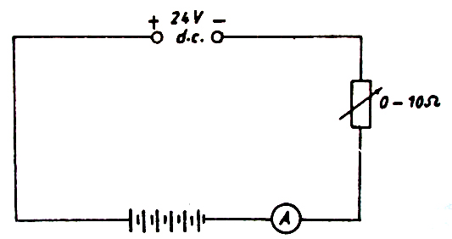

Six accumulators each of e.m.f 2V and each of internal resistance 0.1Ω are charged from a 24 d.c supply as shown above.

(i) Explain why it is necessary to include a rheostat in the circuit

(ii) What will the ammeter read if the rheostat is set to 5.4Ω

(iii) Find the rate at which electrical energy is converted to chemical energy in (ii) above.

5. (a) Describe an experiment to determine the specific latent heat of fusion of ice

(b) Two kilogrammes of ice initially at -100C is heated until it changes to steam at 1000C

(i) Sketch a graph to show how the temperature changes with time

(ii) Calculate the thermal energy required at each end of the graph.

Specific latent heat of fusion of ice=3.36x105Jkg-1

Specific heat capacity of ice =2.1x103JkgK-1

Specific latent heat of vaporization =2.26x106Jkg-1

6. (a) State the laws of reflection of light.

(b) With the aid of ray diagrams.

(i) explain the action of a pin-hole camera.

(ii) distinguish between partial and total eclipses of the moon.

(c) (i) Describe a simple experiment to determine the focal length of a concave mirror

(ii) State and explain one application of a convex mirror

7. (a) State the factors which determine the magnitude of the e.m.f induced in a conductor cutting

at right angles

(b) (i) Describe, with the help of a labeled diagram the action and structure of a simple a.c

generator(alternator)

(ii) Sketch the variation with time of the e.m.f generated by the simple a.c generator

(iii) Use the sketch in(ii) above to explain the terms peak value and frequency of an

alternating e.m.f.

**\*\*\*\*\*\*\*\*\*\***

## Go to Index | [E-mail Designer](mailto:kecan44@mynet.com?subject=Comments%20about%20UCE%20Chemistry%201.0) |

|  |  |  |
| --- | --- | --- |
| **535/2**  **PHYSICS**  **PAPER 2** Nov./Dec. 19892 hours |  | UGANDA NATIONAL EXAMINATION BOARD  **Uganda Certificate of Education**  **PHYSICS**  **Paper 2**  **Time: 2 Hours** |

1. (a) (i) Define the term velocity ?

(ii) Sketch a velocity-time graph for a body traveling with uniform velocity .

(b) A vehicle traveling at a velocity of 90kmh-1 is uniformly brought to rest in 20s.

(i) Calculate the acceleration of the vehicle

(ii) if the vehicle had originally been traveling at the velocity 90kmh-1for 60s, calculate the total distance traveled before it finally stopped.

(c) An inflated balloon is stationary in air. Explain what happens when the air inside is allowed to escape from the nozzle.

2. (a) (i) What is meant by a ductile material?

(ii) What properties would you look for when selecting a material for overhead cables.

(b) (i) State the advantage of glass as a construction material.

(ii) Explain briefly how concrete can be improved so as to withstand tension forces.

(iii) Explain how a plank of wood with cracks on one side may be placed to form a single bridge across a stream

(iv) In the construction of bridges or large structures, hollow tubes of strong metals are used instead of solid ones. What advantages do such structures have?

3. (a) State the principle of moments.

(b) A uniform beam is pivoted at its centre

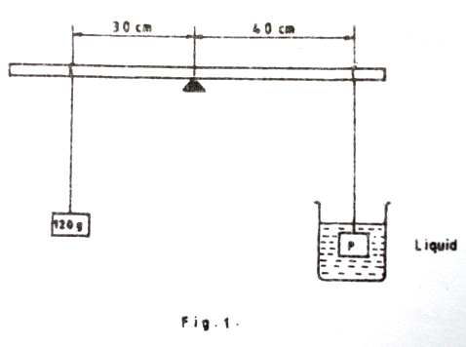

A mass of 120g is suspended at 30cm from the centre of the beam. The beam remains horizontal when a block P suspended at the 40cm mark form the centre of the beam is immersed in a liquid of density 800kgm-3 as shown above. If the volume of the liquid displaced by the block is 10cm3, find

1. the mass if the liquid displaced.
2. the weight of P in air.

4.

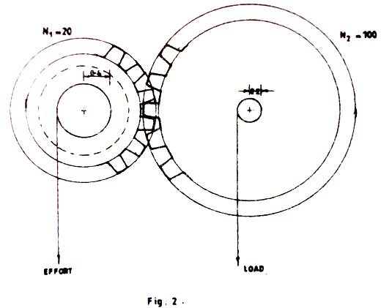

In the gear system above, N1 and N2 are the number of teeth on the wheels. If the shaft radii are 0.4m and 0.2m respectively, and the efficiency is 30%, find

1. the velocity ratio.
2. the load that can be raised by an effort of 200N.

4. (a) (i) Explain the term total internal reflection.

(ii) Calculate the critical angle for a glass-air boundary if the refractive index of glass is 1.60.

(b) With the aid of a diagram explain the dispersion of white light by a glass prism.

(c) Explain the appearance of a blue flag with red stripes when viewed in daylight through a yellow sheet of glass

6. (a) Sketch the electric field patterns for the following

(i) two negative charges close to each other.

(ii) a positively charged hollow conducting sphere.

(iii) two oppositely charged parallel plates

(b) Explain the following observations

(i) the leaves of a positively charged electroscope fall when the cap is touched

(ii) when a positively charged conductor is lowered in an ice pail placed on the cap of an uncharged electroscope, the leaves diverge. When the conductor touches the inside of the pail, the divergence of the leaves is not altered

(c) Explain how a lightning conductor safeguards a house against lightning

6.

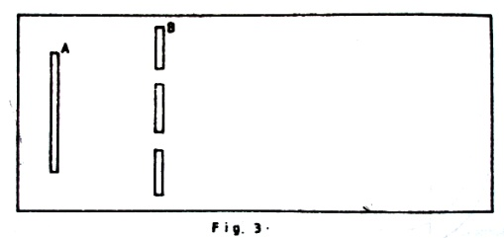

The above diagram is of a cross-section of a ripple tank in which A is a straight dipper and B is a barrier with two gaps.

(a) Sketch a diagram showing waves produced when A vibrates perpendicular to the water surface.

(b) What will happen when

(i) the gaps are made narrower.

(ii) the separation of the gaps is decreased.

(iii) the frequency of vibration of A is decreased.

(c) If A vibrates with a frequency of 20Hz and is 25cm from B, find

(i) the speed of the wave if a wavefront takes 5s from A to B.

(ii) the wavelength of the waves.

(d) State two differences between water and light waves.

7. (a) Define the following terms

(i) volt.

(ii) electrical resistance.

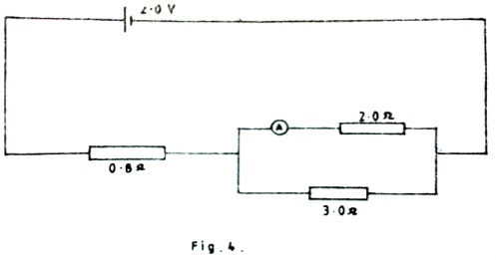

(b) A battery of e.m.f 2.0V and of negligible internal resistance is connected as shown above. Find the reading of ammeter A

(c) A battery of e.m.f 12 V and internal resistance 1 Ω is connected for 3 min, 2 s across a heating coil of resistance 11 Ω immersed in a liquid of mass 0.2 kg and specific heat capacity of 2.0 ×103 Jkg-1K-1. Find the rise in temperature of the liquid. State clearly any assumption made.

8. (a) Explain the following terms as applied to a thin converging lense.

(i) principal focus.

(ii) focal length.

(iii) power.

(b) An object is placed at right angles to the principal axis of a thin converging lens of focal length 10 cm. A real image of height 5cm is formed at 30 cm from the lens. Find by construction the position and height of the object.

(c) With the help of a ray diagram, show how a converging lens can be used as s magnifying glass.

**END**

**\*\*\*\*\*\*\*\*\*\***

## Go to Index | [E-mail Designer](mailto:kecan44@mynet.com?subject=Comments%20about%20UCE%20Chemistry%201.0) |

|  |  |  |
| --- | --- | --- |
| **535/2**  **PHYSICS**  **PAPER 2** Nov./Dec. 19902 hours |  | UGANDA NATIONAL EXAMINATION BOARD  **Uganda Certificate of Education**  **PHYSICS**  **Paper 2**  **Time: 2 Hours** |

1. (a) State the differences between mass and weight of a body

(b) A man of mass 80kg stands in a stationary lift on earth. Calculate his apparent weight when the lift.

(i) Accelerates upwards at a rate of 2ms-2.

(ii) Falls freely under gravity.

(c) A body is fired horizontally with a speed of 30ms-1 form a cliff 500m above the ground. Calculate

(i) the time taken before the body hits the ground.

(ii) the horizontal distance traveled.

2. (a) A radioactive nuclide decays by emitting alpha particles and two beta particles to a

nuclide Y.

1. What is meant by a radioactive nuclide.
2. Give three differences between alpha and beta particles.
3. State the atomic number and mass number of Y.

(b) What precautions would have to be taken when handling radioactive materials

(c) A certain mass of radioactive material contains 2.7x1024 radioactive atoms. How many atoms will have decayed after 3200y if the half life of the material is 1600y

(d) Explain briefly one industrial application of radioactivity.

3. (a) Name one instrument that turns.

(i) Chemical energy to electrical energy.

(ii) heat energy to electrical energy.

(b) With the help of a well labeled diagram, describe how a simple dynamo generates an electromotive force (emf).

(c)

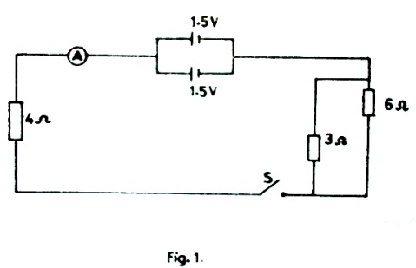

The above figure shows two cells, each if internal resistance 1Ω connected to a circuit which includes switch S

1. What is the reading on the ammeter when switch S is closed.
2. What is the power developed in the 4Ω resistor when switch B is closed.

4. (a) Describe a simple experiment to determine the refractive index of the glass of a triangular

prism.

(b) The angle of refraction in a glass block is 320. Calculate the angle of incidence if the refractive index of the glass is 1.5

(c) A simple magnifying glass of focal length 5cm forms an erect image, of a small object, 25cm from the lens.

(i) By graphical method, find the distance between the object and image.

(ii) Calculate the magnification

5. (a) State

(i) Archimedes principle.

(ii) the law of flotation.

(b) When a metal is completely immersed in liquid A, its apparent weight is 20N. When it is immersed in another liquid B, the apparent weight is 16N. If the density of B is 9/8 times that of A, calculate the mass of the metal.

(c) (i) What is meant by the terms surface tension and diffusion.

(ii) Describe an experiment to demonstrate diffusion in liquids.

(iii) State any two ways by which surface tension of water can be reduced

6. (a) Distinguish between longitudinal and transverse waves. Give one example of each

(b) Describe an experiment to show interference of water waves.

(c) (i) What ate the conditions for the formation of standing water waves.

(ii) Name two instruments where standing water waves are applied.

(d) Describe the resonance method of determining the speed of sound in air

(e) A fork has a frequency of 256Hz. Assuming the speed of sound in air is 320ms-1, calculate the wavelength of the sound note given by the fork.

7. (a) Use the kinetic theory if matter to explain the following observations.

(i) Ice melts faster when salt is sprinkled on it.

(ii) The pressure of a fixed mass of gas at constant volume increases when heated through the same temperature.

(b) A drop of olive oil of volume 0.1mm3 is placed on the surface of clean water. It spreads out completely into a patch of area 100cm2.

(i) Calculate the thickness of the oil patch.

(ii) Estimate the number of molecules in 0.1mm3 of the oil. State any assumptions made.

8. (a) Draw a labeled diagram of a gold leaf electroscope

(b) Describe an experiment to test the charge on charged body using a gold leaf electroscope

(c) Draw the electric field pattern for

(i) Two positively charged bodies a small distance apart.

(ii) An isolated negative charge.

(iii) Two parallel plates with opposite charges at a small distance apart.

**\*\*\*\*\*\*\*\*\*\***

## Go to Index | [E-mail Designer](mailto:kecan44@mynet.com?subject=Comments%20about%20UCE%20Chemistry%201.0) |

|  |  |  |
| --- | --- | --- |
| **535/2**  **PHYSICS**  **PAPER 2** Nov./Dec. 19912 hours |  | UGANDA NATIONAL EXAMINATION BOARD  **Uganda Certificate of Education**  **PHYSICS**  **Paper 2**  **Time: 2 Hours** |

1. (a) (i) What is meant by the terms scalar and vector quantities. Give two examples of each.

(ii) State the condition under which a body is said to be in mechanical equilibrium

(iii)

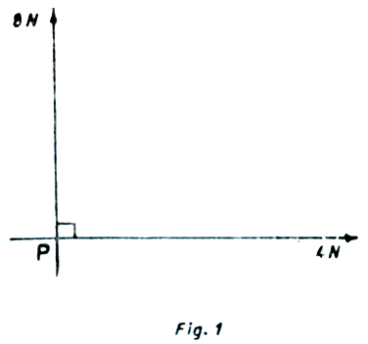

Two forces of 8N and 4N act on a body at P as shown in the above figure. Find the magnitude of the third force needed to keep the body in equilibrium

(b) What is meant by kinetic energy and potential energy

(c)

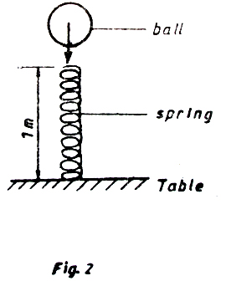

A ball of mass 100g falls from rest through a height of 2m on to the top of a spring of length 1m placed on the table as shown in the above figure.

1. How much energy is passed onto the spring by the ball.
2. If the elastic constant of the spring is100Nm-1, what will be the compression in the spring

2. (a) (i) State the principal of moments.

(ii) Describe how the principal of moments can be verified experimentally.

(iii) State two practical applications of the principal of moments.

(b) Two laborers A and B carry between them a load of weight 500N on a uniform pole of weight 50N. If the pole is 2m long and the load is 50cm from A towards B

(i) Draw a diagram to show the forces acting on the pole.

(ii) Find the fraction of the total weight that is supported by B.

3. (a)

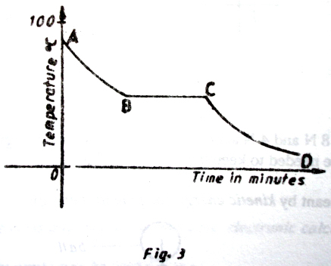

The figure above shows a cooling curve for a substance which is in liquid form at 1000C.

(i) In what states is the substance over the r4egions AB, BC and CD of the curve.

(ii) Use the kinetic theory of matter to explain the difference between the states of the substances over the regions AB and CD

(b) (i) Define specific heat capacity.

(ii) The same amount of heat which raises the temperature of 0.1kg of water from 250C to 600C is used to heat a metal rod of mass 1.7kg and specific heat capacity 300Jkg-1K-1. If the original temperature of the rod is 200C, calculate the final temperature of the rod.

(c) (i) What is saturated vapour?

(ii) Explain why the boiling point depend of altitude.

4. (a) (i) Describe a simple experiment to show that light travels in a straight line

(ii) An object 3cm high is placed at a right angle to the principal axis of a concave mirror of focal length 7.5cm. If the object is 30cm from the pole of the mirror, construct array diagram to obtain the position and size of the image formed (iii) State two applications of a concave mirror.

(b) (i) State the laws of refraction of light.

(ii) Light of the same wavelength is incident from air on glass of refractive index 1.5. If the angle of incidence is 600, find the angle of refraction

5. (a) (i) Describe a simple experiment to determine the velocity of sound in air

(ii) What factors would affect the value of the velocity of sound obtained from the experiment in (i) above.

(b) Explain why a musical note played on a piano sounds different from that played on a guitar

(c) (i) Calculate the wavelength of sound waves of frequency 3.3kHz and speed 330ms-1

(ii) State four differences between sound and radio waves.

6. (a) (i) What are the advantages of ac over dc in mains supply.

(ii) State the safety precautions which must be taken when wiring a house.

(b) (i) What is the meaning of a kilowatt hour(kWh).

(ii) A house has one 100W bulb, two 75W bulbs and five 40w bulbs. Find the cost of having all these bulbs switched on for 2hrs everyday for 30days at a cost of sh.20 per unit.

7. (a) State the law of electrostatics

(b) Describe how two identical metal balls may be charged positively and simultaneously by induction

(c) Draw a labeled diagram of a gold leaf electroscope

(d) (i) Explain what happens when a negatively charged rod is brought near the cap of an

uncharged electroscope and slowly taken away. (ii) How can an electroscope be used to test whether a material is a conductor of an insulator

(e) What precautions should be taken when carrying out experiments in electrostatics

8. (a) (i) Draw a well labeled diagram of a cathode ray oscilloscope(CRO).

(ii) State one function of each of the parts you have labeled in (i) above.

(b)

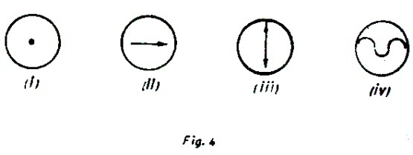

The above diagram shows the traces of cathode ray beam on the screen of a cathode ray tube. Explain how each one may be obtained.

(c) Give two uses of a C.

**END**

**\*\*\*\*\*\*\*\*\*\***

## Go to Index | [E-mail Designer](mailto:kecan44@mynet.com?subject=Comments%20about%20UCE%20Chemistry%201.0) |

|  |  |  |
| --- | --- | --- |
| **535/2**  **PHYSICS**  **PAPER 2** Nov./Dec. 19922 hours |  | UGANDA NATIONAL EXAMINATION BOARD  **Uganda Certificate of Education**  **PHYSICS**  **Paper 2**  **Time: 2 Hours** |

1. (a) (i) What is a magnetic field?

(ii) Draw a diagram of the magnetic field pattern between the North poles of two bar magnets placed near each other

(b) Describe how you can plot the magnetic field around a wire carrying a current perpendicular to the plane of the paper.

(c) Draw a diagram to show what happens when two straight conductors placed vertically near each other carry a current in

(i) the same direction.

(ii) the opposite direction.

(d) Describe briefly two methods of magnetizing an iron rod

(e) A transformer is designed to produce an output of 220V when connected to a 25V supply. If the transformer is 80% efficient, calculate the input current when the output is connected to a 220V, 75W lamp

2. (a) Sketch the current and p.d variation for a semi-conductor diode.

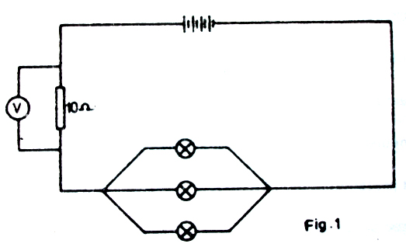

(b) Four identical cells each of internal resistance 0.2Ω are connected to form a battery. Three identical lamps each marked 3W and a10Ω resistor are connected to the battery as shown above. If the current through each lamp is 0.5A, find

(i) the resistance of each lamp.

(ii) the reading of the voltmeter V.

(iii) the effective resistance in the circuit (IV) the energy delivered by the battery per second.

(c) Calculate the cost of running an electric fire for 21/2hrs if the electric fire takes a current of 13A on a 100V appliance and each unit costs sh.40.

3. (a) (i) What is meant by acceleration due to gravity.

(ii) Describe a simple experiment to determine the acceleration due to gravity.

(b) A 5 kg mass is dropped from a height above the ground and hits the ground after 45s.

(i) Find the velocity of the mass as it hits the ground.

(ii) Calculate the kinetic energy of the mass just before it hits the ground.

1. From what height was the mass dropped.
2. State the energy changes of the mass.

4. (a) Give two methods of producing electrons from metals.

(b) State the effect of each of the following on a line beam of electrons

(i) electric field.

(ii) magnetic field.

(c) (i) Explain briefly how x-rays are produced.

(ii) Distinguish between hard x-rays and soft x-rays.

(iii) What precautions should be taken to minimize health hazards

5. (a) (i) State the laws of reflection.

(ii) Describe an experiment to verify the laws of reflection

(b)

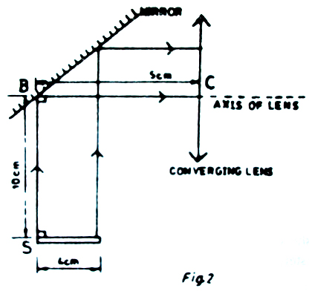

The above figure shows a stick, S, lying on a horizontal ground. Two parallel rays from the stick strike the mirror and are reflected on to the converging lens whose centre is C. The focal length of the lens is 10cm and the distance SB and BC are 10cm and 5cm respectively.

1. State the nature of the image of the stick formed by the lens.
2. Use the graphical method to locate the position of the two images of the stick.
3. Find the magnification of the final image.

6. (a) State what is meant by each of the following terms as applied to simple machines

(i) mechanical advantage

(ii) efficiency

(b) (i) Give two reasons why the efficiency of any practical machine is always less than

100% (ii) State two by which the efficiency of a machine may be increased

(c)

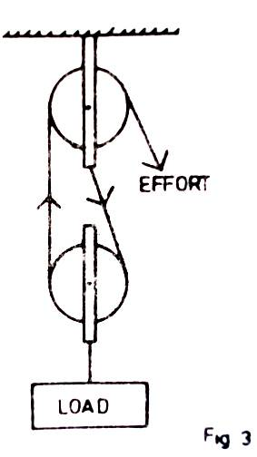

The above figure shows a load of 10N being raised slowly by the aid of a simple frictionless pulley system .

1. What is the velocity ratio of the system.
2. Calculate the effort required to raise the load if the mass of each pulley is 0.2kg.
3. If the load is raised through a distance of 5m in 5s, calculate the efficiency of the system.

7. (a) Define each of the following terms as applied to wave motion

(i) wave front,

(ii) wave-length.

(b) The wave-length of a radio wave is 10 m. Calculate

(i) the frequency

(ii) the period of the wave

(c) Why does sound wave travel faster in solid than in gases

(d) (i) Explain why an open pipe is preferred to a closed pipe when used in producing

different notes.

(ii) the frequency of the third harmonic in a closed is 280 Hz. Find the length of the air column of the pipe

8. (a) (i) Define specific latent heat of fusion of a solid

(ii) Describe a simple experiment to determine the specific latent heat of fusion of ice. State any precautions taken

(b) Use the kinetic theory to explain the occurance of latent heat of fusion

(c) An ice making machine removes heat from water at a rate of 20Js-1. How long will it take to convert 0.5kg of water at 200C to ice at 00C.

**END**

**\*\*\*\*\*\*\*\*\*\***

## Go to Index | [E-mail Designer](mailto:kecan44@mynet.com?subject=Comments%20about%20UCE%20Chemistry%201.0) |

|  |  |  |
| --- | --- | --- |
| **535/2**  **PHYSICS**  **PAPER 2** Nov./Dec. 19932 hours |  | UGANDA NATIONAL EXAMINATION BOARD  **Uganda Certificate of Education**  **PHYSICS**  **Paper 2**  **Time: 2 Hours** |

1. (a) Define pressure?

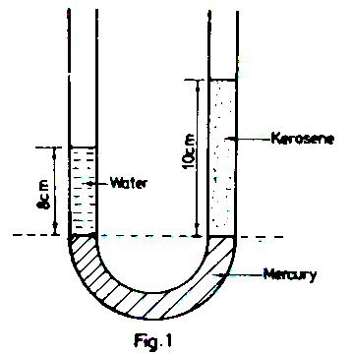

An open U-tube contains columns of water and kerosene over mercury as shown in the above figure. Calculate the density of kerosene

(b) State two factors on which the pressure of a liquid depends. Explain why cooking at a high altitude takes a longer time than at a lower altitude?

(c) With the aid of a labelled diagram, describe how a force pump works.

2. (a) (i) Name the particles emitted by radioactive nuclides.

(ii) Give one property common to the particles named in (i).

(b)

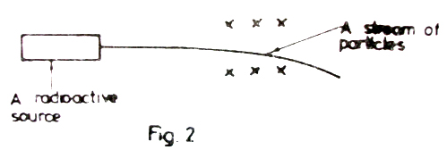

A stream of particles from a radioactive source passes through a magnetic field directed into the plane of the paper as shown in the above figure.

1. Identify the particles in the stream.
2. Sketch a diagram to show the path of the particles in an electric field.

(c) (i) Define half life (ii) *x* grams of a radioactive material of half life of 3 weeks, decays

and 5.12g remains after 15 weeks. Determine the value of *x.*

(d) Distinguish between the terms fusion and fission. State two conditions necessary for each to occur.

3. (a) With the aid of a labelled diagram, describe an experiment to show the relationship between

the volume and temperature of a fixed mass of gas at atmospheric pressure.

(b) A cylinder with a movable piston contains 0.1m3 of air at a temperature of 270C. calculate the volume of the gas if it is cooled to 730C at constant pressure.

(c) Define the term specific heat capacity.

(d) A copper block of mass 250g is heated to a temperature of 1450C and then dropped into a copper calorimeter of mass 250g which contains 250cm3 of water at 200C.

(i) Calculate the maximum temperature attained by the water.

( specific heat capacity of copper = 400 J kg-1K-1)

(ii) Sketch a graph to show the variation of water with time

4. (a) Explain the difference between transverse and longitudinal waves. Give one example of each

(b)

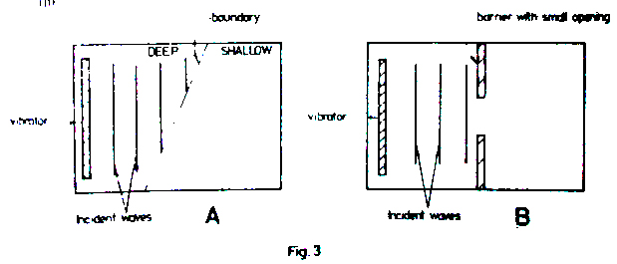

The diagram in the above figure represents a place view of horizontal ripple tanks set up to study characteristics of water waves. The vibrators were set up to produce plane waves

1. Draw diagrams to show the wave patterns in A and B.
2. Explain what happens to the plane waves in each case.

(c) A vibrator in a ripple tank vibrates at 5Hz. If the distance between 10 successive crests is 37.8cm, calculate

(i) the wavelength of the waves.

(ii) the velocity of the waves

5. (a) What is meant by uniform acceleration?

(b) A body of mass 60 kg starts moving with an initial velocity of 15 ms-1 and accelerates uniformly at a rate of 4 ms-2 for 5 s, then maintains a constant velocity for 5 s and comes to rest after 7 s

(i) Draw a velocity-time graph for the motion.

(ii) Calculate the momentum of the body during the 8thsecond.

(iii) Calculate the retarding force

(c)

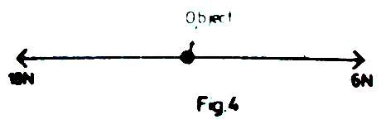

Two forces of 18 N and 6 N act in opposite directions on an object of mass 3 kg as shown in the above figure. Calculate the acceleration of the object.

6. (a) (i) Draw a diagram to show the structure of a simple cell.

(ii) Give one defect of a simple cell and state how it is minimised.

(b) Explain how a lead acid accumulator can be recharged when it has run down.

(c)

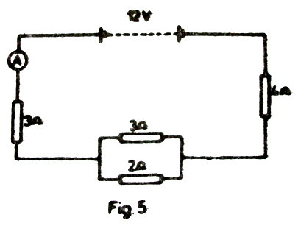

Four resistors are connected across a 12V battery of negligible internal resistance as shown in the above figure. Determine

1. the reading of the ammeter A.
2. the p.d across the parallel combination of resistors.

(d) When two identical heating elements of a kettle are connected in series to a 240 V supply, the power developed is 400 W. find;

(i) the resistance of the either element.

(ii) the power developed when the elements are connected in parallel to the same supply

7. (a) Define

(i) the principal focus of a converging lens

(ii) a virtual image

(b) With the aid of a labelled diagram, describe a simple experiment to determine the focal length of a converging lens

(c) An object of height 4 cm is placed perpendicularly on the principal axis at a distance of 45 cm from a converging lens of focal length of 15 cm. By graphical construction, determine

(i) the position of the image

(ii) the magnification

(d) Give one use of converging lenses

8. (a)

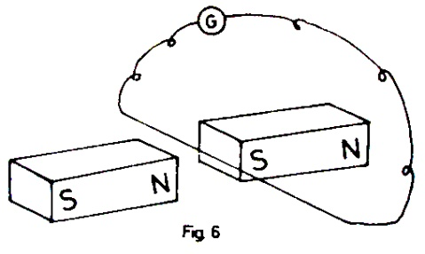

A wire placed between the poles of two permanent magnets is connected to a galvanometer G as shown in the above figure

(b) Explain briefly what is meant by mutual induction.

(i) mention the causes of energy loss by a transformer and state how the loss can be minimised

(ii) A transformer has 200 turns on the primary coil. Calculate the number of turns on the secondary coil if 240V is to be stepped to 415 V.

**END**

**\*\*\*\*\*\*\*\*\*\***

## Go to Index | [E-mail Designer](mailto:kecan44@mynet.com?subject=Comments%20about%20UCE%20Chemistry%201.0) |

|  |  |  |
| --- | --- | --- |
| **535/2**  **PHYSICS**  **PAPER 2** Nov./Dec. 19942 hours |  | UGANDA NATIONAL EXAMINATION BOARD  **Uganda Certificate of Education**  **PHYSICS**  **Paper 2**  **Time: 2 Hours** |

1. (a) Differenciate between conduction and convection.

(b) Describe an experiment which can be performed to show convection in a liquid.

(c) (i) Draw a labelled diagram of a vacuum flask.

(ii) Explain how a vacuum flak minimises heat loses.

(d) Why is a car radiator made of fins and painted black.

2. (a) State three factors on which the magnitude of the force exerted on a wire carrying a current

in a magnetic field depends.

(b) With the aid of a labelled diagram, describe the action of a moving coil loud speaker.

(c) A moving coil galvanometer has a coil of resistance 4 Ω and gives a full scale deflection when a current of 25 mA passes through it. Calculate the value of the resistance required to convert to an ammeter which reads 15 A at full scale deflection

3. (a) State Newton’s laws of motion.

(b) A water jet directed to a spot on the ground digs a hole in the ground after sometime. Explain

(c) A moving ball P of mass 100 g collides with a stationary ball Q of mass 200 g. After

collision, P moves backwards with a velocity of 2ms-1 while Q moves forwards with a velocity of 5ms-1. Calculate

1. the initial velocity of P.
2. the force exerted by P on Q if the collision took 0.03s.

(d) Explain the principal of operation of a rocket engine.

4. (a) Explain the phenomenom of dispersion applied to white light.

(b) Draw a ray diagram to show the dispersion of white light by a glass prism.

(c) Distinguish between secondary and primary colours. Give one example of each.

(d) Name the colour that would be obtained when the following coloured lights are mixed

(i) Green and red.

(ii) cyan and red

(e) Explain why an object illuminated by white light appears

(i) coloured.

(ii) black.

5. (a) Define the volt?

(b) Draw a circuit diagram which can be used to investigate the p.d-current relationship for a wire.

(c) Sketch a graph of current against p.d for

(i) carbon resistor

(ii) a semi-conductor diode

(d) An accumulator of e.m.f 24V and internal resistance of 2Ω is connected to 3Ω, 4Ω, 2Ω and 6Ω as shown in the figure below.

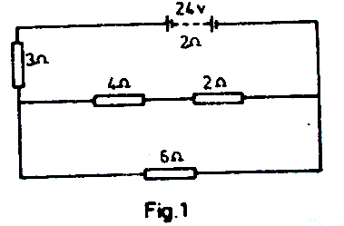

Calculate;

1. the current through the 6Ω resistor,
2. the total power expended.

(e) State two precautions which must be taken to protect an accumulator

6. (a) Define the terms atomic number and mass number.

(b) When lithium is bombarded by neutrons, a nuclear reaction occurs which is represented by the following equation

63*Li* + 10*n → 31H + P* .

Complete the equation and name P.

(c) Describe the application of radioactivity in determining the age of fossils (remains of old plants and animals).

(d) The half life of Uranium is 24 days. Calculate the mass of Uranium which remains after 120days if the initial mass is 64 g.

(e) Give two harmful effects of radioactivity.

(f) State three differences between cathode rays and x-rays.

7. (a) Define the terms strain and stress.

(b) The figure below shows a diagram of a bicycle.

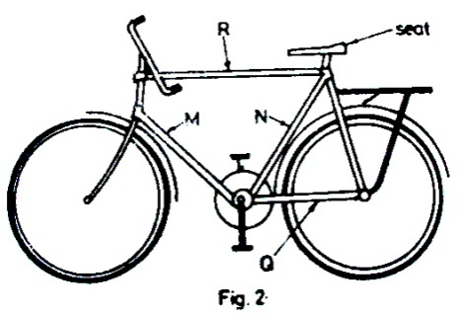

Which of the parts labelled M, N, Q and R would be

1. in tension
2. in compression when a heavy person sits on the seat

(c) Give four reasons why bicycle frames are made of hollow cylindrical structures

(d) Explain why the lower part of the second floor of a building is made of reinforced concrete while the upper part is not reinforced.

(e) The figure below shows a part of a roof structure

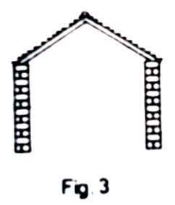

1. Copy the diagram and on it show how the structure can be strengthened by using two other girders.
2. Label one tie and one strut on your diagram.

8. (a) Explain each of the following observations

(i) Sound from a distant source is louder at night than during day.

(ii) An observer can hear sound from a source which is behind a building.

(b) Describe an experiment to show interference of sound waves.

(c) A man stands between two cliffs and makes a loud sound. He hears the first echo after one second and a second echo after a further one second. Find the distance between the cliffs

(d) Straight water waves travel from deep to shallow water as shown in the figure below

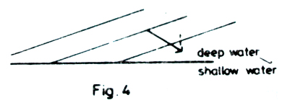

Copy and complete the wave front pattern in the shallow water.

**END**

**\*\*\*\*\*\*\*\*\*\***

## Go to Index | [E-mail Designer](mailto:kecan44@mynet.com?subject=Comments%20about%20UCE%20Chemistry%201.0) |

|  |  |  |
| --- | --- | --- |
| **535/2**  **PHYSICS**  **PAPER 2** Nov./Dec. 19952 hours |  | UGANDA NATIONAL EXAMINATION BOARD  **Uganda Certificate of Education**  **PHYSICS**  **Paper 2**  **Time: 2 Hours** |

1. (a) The figure shows the main parts of a cathode ray oscilloscope.

Identify the parts labelled U, V and X and briefly describe their functions

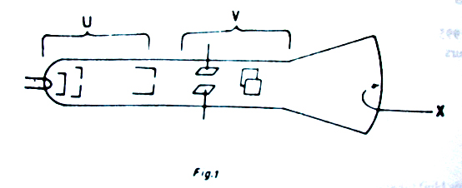

(b) (i) Name the particles emitted by the radioactive materials

(ii) Draw diagrams to show the path of the particles named in (b) (i) and in a cloud chamber.

(c) A Zinc cathode was enclosed in an evacuated glass tube as shown in the figure

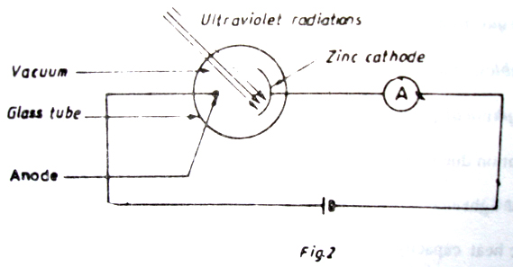

When the cathode was irradiated with ultra violet radiations, the ammeter gave a reading

1. Explain why the ammeter gave a reading.
2. A gas was gradually introduced into the glass tube. Explain what happened?

2. (a) Explain each of the following observations

(i) An inflated bicycle tube may burst when left in a hot place.

(ii) Large water reservoirs are much wider at the base than at the top.

(b) The figure shows the structure of a force pump.

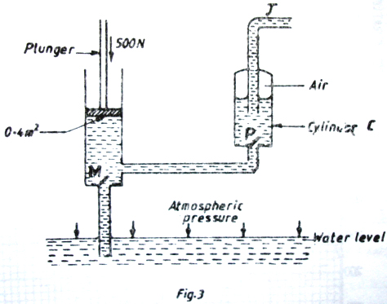

1. Describe the action of the pump.
2. If a downwards force of 500N is exerted on the plunger whose surface area is 0.4m2. Calculate the pressure which forces water into cylinder C

3. (a) What is the difference between speed and velocity?

(b) The graph in the figure shows the variation of distance with time for a body. Describe the motion of the body.

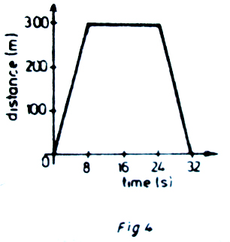

(c) Describe an experiment to demonstrate friction compensation using an inclined plane.

(d) The figure shows dots produced on a tape pulled through a ticker-timer by a moving body.

The frequency of the ticker-timer is 50Hz. Calculate the acceleration of the body.

4. (a) The diagram in the figure shows a ray of yellow light incident at an angle of 500 on one side

of an equilateral glass prism of refractive index 1.52.

****

1. Calculate the angles marked R and C.
2. Sate and explain what could be observed if the ray above were of white light.

(b) Explain with the aid of a diagram why the writing on a piece of paper placed under a glass block appears raised when observed from above.

(c) State (i) the conditions necessary for total internal reflection to occur.

(ii) One application of total internal reflection.

5. The graph below shows the variations of current through a tungsten filament with the p.d across it.

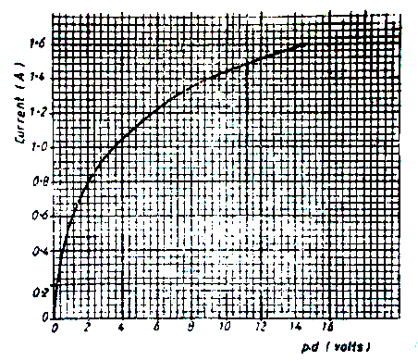

1. Draw a suitable circuit diagram to show how the results in the graph can be obtained.
2. State what happens to the resistance of the filament as the current increases.
3. Using the graph, determine the resistance of the filament when the current is 0.7A

(b) An electric heater of resistance 40Ω is connected to a 240 V mains. How long will it take to raise the temperature of 4kg of water from 400C to 1000C?

(c) With the aid of a labelled diagram, explain how a dry cell works.

6. (a) Describe a simple experiment to show the existence of surface tension in water

(b) A solution is made by dissolving 1cm3 of cooking oil in 199cm3 of the methanol. When 0.004cm3 of the solution is dropped on the surface of water, an oil film of diameter 12cm is obtained.

(i) Estimate the thickness of a molecule of the cooking oil

(ii) State any assumption made in

(b) (i) .

(c) Smoke confined in an illuminated cell is observed through a microscope.

(i) State what is observed.

(ii) What conclusion can be drawn from the observations in (c) (i) ?

7. (a) Explain how a piece of iron can be magnetised by a single touch method illustrate your

answer with a diagram.

(b) How can you determine the polarity of a magnet?

(c) Explain why a magnet loses its magnetism when placed in a coil of a wire carrying alternating current.

(d) Describe the motion of a beam of electrons directed midway between the north and the south poles of a permanent magnet .

8. (a) Two identical sources are made to produce circular waves in a ripple tank. With the aid of a

diagram, explain how interference fringes may be obtained.

(b) State two similarities between water waves and electromagnetic waves.

(c) Describe a simple method of detecting ultra violet radiations.

(d) A radio station broadcasts on 49m band.

(i) What is meant by the above statement?

(ii) Calculate the frequency of the broadcast.

(iii) Explain how radio waves are transmitted.

**END**

**\*\*\*\*\*\*\*\*\*\***

## Go to Index | [E-mail Designer](mailto:kecan44@mynet.com?subject=Comments%20about%20UCE%20Chemistry%201.0) |

|  |  |  |
| --- | --- | --- |
| **535/2**  **PHYSICS**  **PAPER 2** Nov./Dec. 19962 hours |  | UGANDA NATIONAL EXAMINATION BOARD  **Uganda Certificate of Education**  **PHYSICS**  **Paper 2**  **Time: 2 Hours** |

**\*\*\*\*\*\*\*\*\*\***

## Go to Index | [E-mail Designer](mailto:kecan44@mynet.com?subject=Comments%20about%20UCE%20Chemistry%201.0) |

|  |  |  |
| --- | --- | --- |
| **535/2**  **PHYSICS**  **PAPER 2** Nov./Dec. 19972 hours |  | UGANDA NATIONAL EXAMINATION BOARD  **Uganda Certificate of Education**  **PHYSICS**  **Paper 2**  **Time: 2 Hours** |

**1.** (a) State the principle of moments.

(b) A uniform metre ruler of weight 1N is pivoted on a wedge 5cm away from one end and suspended by a string 30cm from the other end.

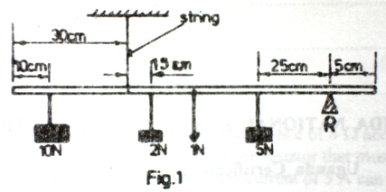

If the metre rule is in equilibrium when weights of 10N, 2N and 5N are attached to it as shown in the above figure, calculate the;

(i) tension in the string

(ii) normal reaction, R, at the wedge.

(c) (i) What is meant by dynamic friction?

(ii) Describe with the aid of a diagram, an experiment to determine the limiting friction between two surfaces in contact.

(iii) State any one factor which affects friction.

(d) Give one application of friction.

2. (a) What do you understand by the following terms as applied to motion;

(i) uniform velocity

(ii) uniform acceleration?

(b) The table below shows the variation of a velocity with time for a body which has been thrown vertically upwards from the surface of a planet.

|  |  |  |  |  |  |  |
| --- | --- | --- | --- | --- | --- | --- |
| Velocity (ms-1) | 8 | 6 | 4 | 2 | 0 | -2 |
| Time (s) | 0 | 1 | 2 | 3 | 4 | 5 |

(i) What does the negative velocity mean?

(ii) Plot a graph of velocity against time.

(iii) Use the graph in b (ii) to find the acceleration due to gravity on the planet.

(iv) Use the graph in b (ii) to find the total distance travelled.

(v) If the body weighs 34 N on earth, what is its weight on the planet?

3. (a) State the kinetic theory of matter.

(b) State the law of volume and temperature (Charle’s law). The volume of a fixed mass of gas at a given pressure is 1.5m3 at 300K. At what temperature will the volume of the gas be 0.5m3 at the same pressure?

(c) Describe an experiment to determine the fixed points of a thermometer.

(d) (i) Mention any three reasons for not using water as a thermometric liquid.

(ii) When a Celsius thermometer is inserted on a boiling liquid, the mercury thread rises above the lower fixed point by 19.5 cm. Find the temperature of the boiling liquid if the fundamental interval is 25cm.

4. (a) Describe an experiment to demonstrate the laws of reflection of light.

(b) With the aid of a diagram, illustrate how the shadows are formed when an opaque object is placed between an extended source of light and a screen.

(c) An object 10cm high is placed at a distance of 25cm from a convex mirror of focal length 10cm.

(i) Draw a ray diagram to locate the position of the image.

(ii) Calculate the magnification.

(d) Give reasons for use of convex mirrors in vehicles.

5. (a) List three differences between sound waves and radio waves.

(b) The figure shows waves propagating towards a concave reflector.

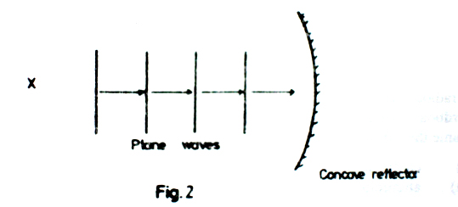

1. Draw a diagram to show how the waves will be reflected.
2. If the velocity of the waves is 320ms-1 and the distance between two successive crests is 10cm, find the period of the waves.

(c) Describe a simple echo method of determining the speed of sound in the air.

6. (a) What is an alpha particle?

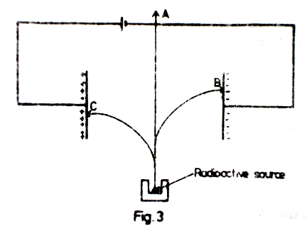

(b) A radio active source decays by emission of all the three radiations. The radiation centre normally into an electric field as shown in the figure above. Which radiations are most likely to be detected at

(i) position A.

(ii) position B.

(iii) position C.

(c)

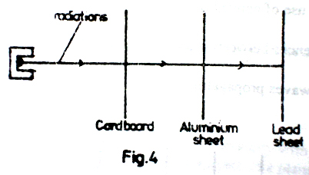

A radioactive source which emits all the there radiations is placed in front of a cardboard, aluminium and lead sheets as shown in the figure above. Name the radiations likely to be between the:

1. cardboard and the aluminium sheet,
2. aluminium and lead sheets.

(d) Name any three precautions which must be under taken by one working with ionising radiation.

(e) Name one:

(i) industrial use,

(ii) biological use, of radioactivity.

(f) A radioactive material of mass 8g has a half–life of 20 days. Find how much of it will decay after 60days?

7. (a) What is a transformer?

(b)

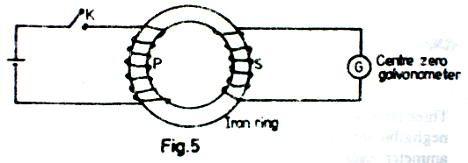

The diagram in the figure above shows a model of a transformer in which the primary coil, P is connected to d.c and the secondary coil, S is connected to a galvanometer.

1. what is observed just as the switch K is closed?
2. What would be the effect of closing switch K very fast in (i) above?
3. What is observed when the switch K is left closed?

(iv) What is observed just as switch K is opened?

(v) What would be observed if the d.c. source is replaced by an a.c. source of low frequency?

(c) A transformer of efficiency 80% is connected to 240 V a.c. supply to operate a heater of resistance 240 Ω. If the current flowing in the primary circuit is 5 A,

(i) calculate the potential difference (p.d) across the heater.

(ii) If the transformer is cooled by oil of specific hest capacity 2100 J kg-1 K-1 and the temperature of the oil rises by 200 in 3 minutes, find the mass of the oil in the transformer.

8. (a)

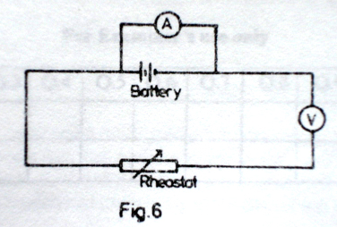

An ammeter *A* and a voltmeter *V* are connected in a circuit as shown in the figure above. What can you say about these connections?

(b)

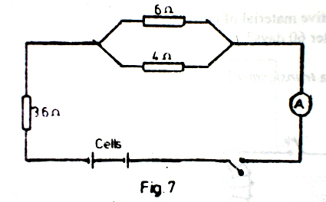

Three resistors of 6Ω, 4Ω and 3.6Ω are connected to eight identical cells of negligible internal resistance connected in series as shown in the figure above. If the ammeter reads 2A, when the switch is closed, determine the:

1. current through the 4Ω resistor.
2. e.m.f of each cell.

(c) Abbot paid an electricity bill of sh.180 after using two identical bulbs for two hours everyday for 10 days at a cost of sh.60 per unit.

(i) Determine the power consumption by each of the bulbs.

(ii) State the energy changes that occur in the bulb.

**END**

**\*\*\*\*\*\*\*\*\*\***

## Go to Index | [E-mail Designer](mailto:kecan44@mynet.com?subject=Comments%20about%20UCE%20Chemistry%201.0) |

|  |  |  |
| --- | --- | --- |
| **535/2**  **PHYSICS**  **PAPER 2** Nov./Dec. 19982 hours |  | UGANDA NATIONAL EXAMINATION BOARD  **Uganda Certificate of Education**  **PHYSICS**  **Paper 2**  **Time: 2 Hours** |

1. (a) Distinguish between the weight and mass of a body.

(b) The force of gravity on the moon is one- sixth of that on the earth. Determine the weight of a 12 kg mass on the moon?

(c) (i) What is meant by centre of gravity?

(ii) Describe an experiment to determine the centre of gravity of an irregular lamina

(d) (i) Sketch the distance- time graph for a body falling freely from rest.

(ii) An object is released from rest at a height of 0.5 km. how long does it take to reach the ground?

2. (a) Distinguish between boiling and evaporation.

(b) The graph below shows a cooling curve of a liquid. Describe the main features of the curve.

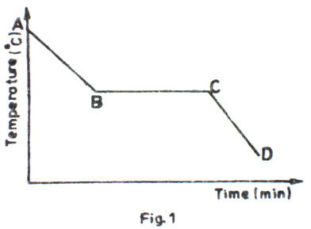

(c) (i) Define the term specific latent heat of fusion.

(ii) A copper can of mass 0.2kg contains 0.20kg of water at 100C. The can and its contents are placed in a refrigerator. Calculate the quantity of heat given out if the temperature of the can and its contents falls to -20C.

(d) Name two main features of a vacuum flask which enable it to keep a liquid warm.

3. (a) Define efficiency of a machine.

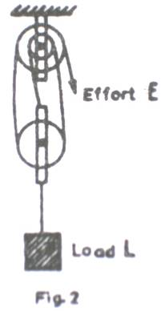

(b) The above diagram represents a pulley system in which an effort, E is applied to raise the load, L.

(i) Copy the diagram and indicate the forces acting on the string.

(ii) What is the velocity ratio of the system?

1. How far will the load move if the effort moves by 2.4 m?
2. What effort will just raise a load of 960 N, if the mechanical advantage is 2.4?
3. Use your results above to calculate the efficiency of the pulley system.

(c) (i) Draw a sketch graph to show how the mechanical advantage of the pulley system in

(b) varies with the load.

(ii) Explain the features of the sketch in (c) (i).

(d) Give two practical examples where pulley systems are used

4. (a) (i) What is meant by a radio isotope?

(ii) State one industrial application of radio isotopes.

(b) Describe what happens when a beam of radiation consisting of α-, β- and γ- rays is incident on a thin sheet of lead.

(c)

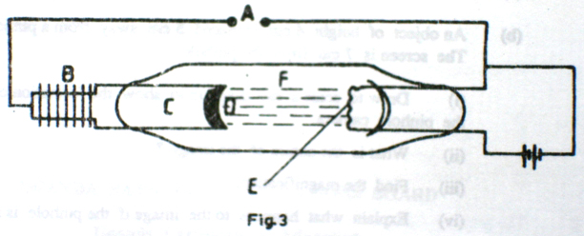

The diagram above shows the essential parts of an X-ray tube.

1. Name the parts labelled A, B, C, D, E and F.
2. State the function of each part.
3. Describe how X-rays are produced.

(d) What safety precautions must be taken in an X-ray laboratory?

5. (a) What is an echo?

(b) (i) Describe an experiment to measure the speed of sound in air.

(ii) State any two likely sources of error in the experiment.

(c) Describe an experiment to determine how frequency of a vibrating string depends on the length of the string.

6. (a) (i) Distinguish between a conductor and an insulator.

(ii) Describe , stating the observation made, how a gold leaf electroscope can be charged positively

(b) A cell of e.m.f , E and internal resistance 1.0Ω is connected in series with a 2Ω resistor as shown in the figure below. The voltmeter reads 1.5V when the switch is open.

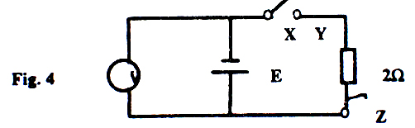

1. What is meant by e.m.f of a cell.
2. Find the value of E.
3. What will the voltmeter read when the switch is closed.
4. What will the voltmeter read if X is connected to Z? Give reasons for your answer?

7. (a) Describe an experiment to show that light travels in a straight line.

(b) An object of height 4cm is placed 5cm away from a pin-hole camera. The screen is 7cm from the pinhole.

(i) Draw a scale a ray diagram to show the formation of the by the pinhole camera.

(ii) What’s the nature of the image?

1. Find the magnification.
2. Explain what happens to the image if the pinhole is made larger

(c) Draw a diagram to show the formation of a solar eclipse

8. (a) Describe a simple experiment to measure the internal resistance of a cell.

(b)

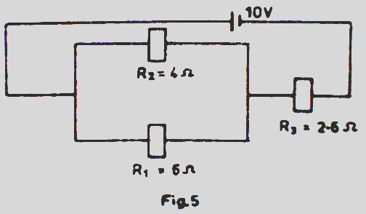

A battery of e.m.f 10 V and negligible internal resistance is connected to resistors R1, R2 and R3 of resistances 6 Ω, 4 Ω and 2.6 Ω respectively as shown in the above figure

1. Calculate the effective resistance of the circuit.
2. Find the rate at which the electrical energy is converted to heat energy in R3.

**END**

**\*\*\*\*\*\*\*\*\*\***

## Go to Index | [E-mail Designer](mailto:kecan44@mynet.com?subject=Comments%20about%20UCE%20Chemistry%201.0) |

|  |  |  |
| --- | --- | --- |
| **535/2**  **PHYSICS**  **PAPER 2** Nov./Dec. 19992 hours |  | UGANDA NATIONAL EXAMINATION BOARD  **Uganda Certificate of Education**  **PHYSICS**  **Paper 2**  **Time: 2 Hours** |

1. (a) Define the term *acceleration*.

(b) A body attached to a string is swung in a vertical circular path in air as shown in figure 1.

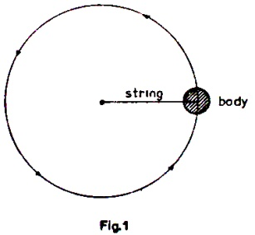

Copy the above diagram and on it indicate and name all the forces acting on the body if the body is moving in an anti-clockwise direction.

(c) Explain why the weight of an object on the Earth’s surface may vary from one place to another.

(d) A ball of mass 0.25kg is dropped from rest at a height of 20 m above the ground.

(i) Calculate the time it takes to reach the ground.

(ii) If the ball bounced once on hitting the ground and lost 20% of its original energy, calculate the maximum height the ball reached again.

2. (a) Define the following terms: (i) *mechanical advantage* (ii) *velocity ratio*.

(b)

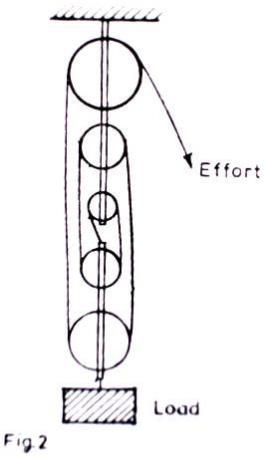

The diagram in Figure 2 shows a pulley system used to raise a load.

(i) What is the velocity ratio of the system?

(ii) Find how far the load is raised, if the effort moves down by 4m.

(iii) Calculate the effort required to raise a load of 800N, if the mechanical advantage of the system is 4.

(iv) Calculate the efficient of the system.

3. (a) Define the term specific latent heat of vaporization.

(b) Describe an experiment to determine the specific latent heat of vaporization of steam.

(c) A copper container of the heat capacity 60 J kg-1 contains 0.5 kg of water at 20oC. Dry steam is passed into the water until the temperature of the container and water reaches 50oC. Calculate the mass of steam condensed.

(d) (i) What is meant by saturated vapour pressure?

(ii) Explain what may happen when one is to cook food from a very high altitude.

4. (a) (i) Describe how the speed of waves in a ripple tank can be decreased.

(ii) Explain the effect of decreasing the speed of the wave in (a) (i) on frequency

(b) With the aid of sketch diagrams, explain the effect of size of a gap on diffraction of waves

******

(c) (i) Give two reasons why sound is louder at night than during the day.

(ii) An echo sounding equipment on a ship receives sound puzzles reflected from the sea bed after they were sent out from it. If the speed of sound in water is 1500ms-1, calculate the depth of water under the ship.

(d) Identify two differences between water and sound waves

5. (a) With the aid of diagrams, distinguish between diffuse and regular reflection

(b) A ray from a bulb makes an angle of 300 with a plane reflector and a ray from the barrel makes an angle of 600 to the same reflector at the same point, M as shown in the above figure. Find the angle through which the reflector must be rotated about M such that the ray from the barrel of the gun falls on the bird.

(c) With the aid of a diagram, explain why a parabolic mirror is most suitable in car head lights

(d) List three uses of concave mirrors

6. (a) Explain what happens when a magnet is

(i) dipped in iron filings

(ii) freely suspended in air

(b)

****

A powerful magnet Q is placed on a soft board. Plastic pins are firmly stuck in soft boards around the magnet. An identical magnet P is held in the space surrounded by the pins above the magnet Q. when the magnet P is released, it floats above the magnet Q as shown in the above figure

1. Explain why P floats above Q
2. Why are plastic pins used instead of steel pins
3. What would happen to magnet P if all the pins were removed at the same time?

(c) Explain in terms of the domain theory how a steel bar gets magnetized by stroking

7. (a) Draw sketch graphs of p.d, V against current, I, for the following

(i) a wire

(ii) an electrolyte

(iii) a semi conductor diyote

(b) Explain the differences between a voltimeter and an ammeter interms of their

(i) constuction

(ii) use

(c) State three physical properties that affect the resistance of a solid conductor.

(d) Two cells each of e.m.f 1.5V and negligible internal resistance are connected in series across two resistors of 2Ω and 3Ω as shown in the above figure. Calculate the current

1. supplied by the cells,
2. that passes through the 3Ω resistor.

8. (a)

*****

The above diagram shows the main parts of a cathode ray oscilloscope(C.R.O)

1. Name the parts labelled A,B and C.
2. Why is the C.R.O evacuated?

(b) (i) Describe briefly the pricipals of operation of C.R.O.

(ii) How is the bright spot formed on the screen?

(c) Use diagrams to show what is observed on the screen of a C.R.O when

(i) the C.R.O is switched on and no signal is applied on the Y-plates.

(ii) the time base is switched on and no signal is applied on the Y-plates.

(iii) an alternating signal is applied on the Y-plates while the time base is switched off.

(d) Give two uses of the C.R.O.

**END**

**\*\*\*\*\*\*\*\*\*\***

## Go to Index | [E-mail Designer](mailto:kecan44@mynet.com?subject=Comments%20about%20UCE%20Chemistry%201.0) |

|  |  |  |
| --- | --- | --- |
| **535/2**  **PHYSICS**  **PAPER 2** Nov./Dec. 20002 hours |  | UGANDA NATIONAL EXAMINATION BOARD  **Uganda Certificate of Education**  **PHYSICS**  **Paper 2**  **Time: 2 Hours** |

1. (a) Define displacement.

(b) Two vehicles A and B accelerate uniformly from rest. Vehicle A attains a maximum velocity of 30ms-1 in 10s swhile vehicle B attains a maximum velocity of 40ms-1 in the same time. Both vehicles maintain these velocities for 6 s. they are then decelerated such that A comes to rest after 6 s while B comes to rest after 4 s.

(i) Sketch on the same axes a velocity-time graph for the motion of the vehicles.

(ii) Calculate the velocity of each vehicle 18 s after the start.

1. How far will the two vehicles be from one another during this moment in

(ii) above?

(c) Describe a simple experiment to measure the acceleration due to gravity.

2. (a) Define the term *pressure*.

(b) (i) Describe how a simple mercury barometer can be set up to measure the atmospheric

pressure.

(ii) The difference between the atmospheric pressure at the top and bottom of a mountain is 1 × 104 N ms-2. If the density of air is 1.25 kg m-3, calculate the height of the mountain.

(c) (i) State the principle of transmission of pressure in fluids.

(ii) Give one assumption on which the principle is based.

1. State two applications of the principle.
2. In figure one, piston A has diameter of 14 cm while B has diameter of 280 cm. if a force of 77 N is exerted on piston A, calculate the force exerted by piston B.

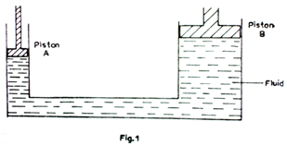

3. (a) What is meant by *latent heat of vaporization*?

(b) With the aid of a labelled diagram describe how a refrigerator works.

(c) The cooling system of a refrigerator extracts 0.7 kW of heat. How long will it take to convert 500g of water at 20oC into ice?

(d) Explain how evaporation taken place.

4. (a) Name the electromagnetic radiation which

(i) causes sensation of heat.

(ii) passes though a thin sheet of lead.

1. is used in satellite communication.
2. is used for remote control of a television receiver.

(b) Figure 2 shows the main parts of an x-ray tube.

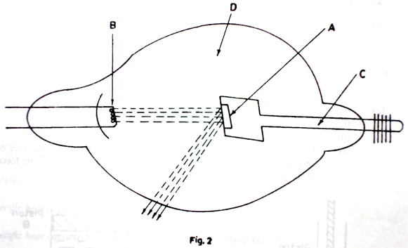

(b) Name the parts labelled A, B, C and D.

(c) List in order the energy changes which occur in the x-ray tube.

(d) Describe one industrial use of x-rays.

(e) (i) What is meant by the *half-life of a radioactive material*?

(ii) The activity of a radioactive source decreases from 4000 counts per minute to 250 counts per minute in 40 minutes. What is the half-life of the source?

5. (a) Explain the causes of reflection of light.

(b) Describe an experiment you would use to measure the refractive index of glass using a glass block.

(c) (i) State the conditions for total internal reflection to occur.

(ii) State one application of total internal reflective.

(iii) Calculate the critical angle for an air-glass interface if refractive index of glass is 1.5.

6. (a) State three difference between sound and light waves.

(b) (i) Explain how stationery waves are formed.

(ii) State three main characteristics of stationery waves.

(c) (i) Define the terms *frequency* and *wavelength* as applied to sound.

(ii) Describe an experiment to demonstrate resonance in sound.

(d) The velocity and frequency of sound in air at a certain time were 320 ms-1 and 200 Hz respectively. At a later time, the air temperature changed and the velocity of sound in air was found to be 340ms-1. determine the change in wavelength of the sound.

7. (a) What happens when a glass rod is rubbed with:

(i) silk

(ii) an identical glass rod?

(b) Describe how a gold leaf electroscope may be used to test the nature of the charge on an object.

(c) Draw the electric field patterns for:

(i) an insulated negative charge.

(ii) two oppositely charged parallel plates at a small distance apart.

(d) Explain why it is not advisable to touch the copper strip of a lightening conductor when it is raining.

8. (a) Describe the structure and action of a fluorescent tube.

(b) Give one advantage of a fluorescent tube over a filament lamp.

(c) Describe the functions of:

(i) a fuse

(ii) an earth wire.

(d) describe briefly how power is transmitted from a power station to a home.

(e) Find the cost of running two 60 W lamps for 20 hours if the cost of each unit is sh.40.

**\*\*\*\*\*\*\*\*\*\***

## Go to Index | [E-mail Designer](mailto:kecan44@mynet.com?subject=Comments%20about%20UCE%20Chemistry%201.0) |

|  |  |  |
| --- | --- | --- |
| **535/2**  **PHYSICS**  **PAPER 2** Nov./Dec. 20012 hours |  | UGANDA NATIONAL EXAMINATION BOARD  **Uganda Certificate of Education**  **PHYSICS**  **Paper 2**  **Time: 2 Hours** |

1. (a) State the principle of conservation of linear momentum. (1mark)

(b) A trolley P of mass 150 g moving with a velocity of 20 ms-1 collides with another stationary trolley Q of mass 100 g. If P and Q move together after collision, calculate

(i) the momentum of P before collision. (3marks)

(ii) the velocity with which P and Q move after collision. (3 marks)

(c) Figure1 represents a velocity-time graph for the motion of the car.

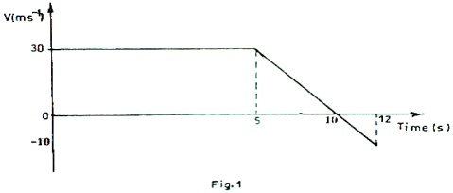

If the mass of car is 500 kg, find

(i) the distance it has traveled from the start of its motion. (4marks)

(ii) the time it takes to get back to the starting point if its velocity is then maintained constantly. (2marks)

(iii) the momentum of the car just before deceleration. (3marks)

2. (a) State Archimedes’ principle. (1mark)

(b) (i) Describe an experiment to verify the law of flotation. (6marks)

(ii) Give one example where the law of floatation is applied. (1 mark)

(c) (i) Define density. (1 mark)

(ii) A piece of glass weighs 0.5N in air and 0.30N in water.

Find the density of glass. (7marks)

3. (a) With the aid of a labeled diagram, describe an experiment to show how the volume of a gas

varies with pressure at constant temperature. (6marks)

(b) A gas of volume 1000 cm3 at a pressure of 4.0 x 105Pa and temperature 170C is heated to 89.50C at constant pressure. Find the new volume of the gas. (4marks)

(c) A balloon is filled with 50 cm3 of hydrogen and tied to the ground. The balloon alone , and the container which it carries have a mass of 2.0 kg. If the densities of hydrogen and air are 9.0 x 10-2 kgm-3 and 1.29 kgm-3 respectively, how much load can the balloon lift when released? (6marks)

4. (a) Describe a simple structure of the atom. (4marks)

(b) Define the following;

(i) atomic number (1mark)

(ii) isotopes of an element (1mark)

(c) State two differences between an α- and a β-particle (2marks)

(d) (i) What is meant by nuclear fission and nuclear fusion. (2marks)

(ii) Give one example where each one occurs. (2marks)

(e) The half-life of a radioactive substance is 24 days. Calculate the mass of the substance which has decayed after 72 days if the original mass is 0.64 g. (4marks)

5. (a) With the aid of a diagram, explain the terms amplitude and wavelength as applied to wave

motion. (2marks)

(b) Derive an equation relating velocity, v, frequency, f and wave length, λ of a wave. (4marks)

(c) (i) List 4 properties of electromagnetic waves. (3marks) (ii) A long open tube is partially immersed in water and a tuning fork of frequency

425 Hz is sounded and held above it. If the tube is gradually raised, find the length of the air column when resonance first occurs.

(Neglect the end correction, Speed of sound in air = 340ms-1) (4marks)

6. (a) Describe briefly the structure and action of an a.c transformer. (5marks)

(b) (i) State any three causes of energy loss in a transformer.

(ii) how are these losses reduced in a practical transformer. (3marks)

(c) Explain why it is an advantage to transmit electrical power at high voltage. (3marks)

(d) Electric power is generated at 11 kV. Transformers are used to raise the voltage to 440kV for transmission over large distances using cables. The out put of the transformers is 19.8 Mw and they are 90% efficient. Find

(i) the input current to the transformer. (3marks)

(ii) the output current to the cables. (2marks)

7. (a) With the aid of a diagram, explain briefly how a pure spectrum may be produced.

(6marks)

(b) (i) What are primary colours? Name them. (2marks)

(ii) Explain briefly what happens when white light falls on a green body. (2marks)

(c) With the aid of a labeled diagram, describe how a lens camera works. (6marks)

8. (a) Draw the magnetic field pattern due to an electric current in;

(i) a circular coil. (2marks) (ii) a solenoid (2marks)

(b) With the aid of a labeled diagram, describe briefly the action of an electric bell. (7marks)

(c) What is meant by the following;

(i) magnetic meridian (1mark) (ii) neutral point in a magnetic field? (1mark)

(d) Describe briefly how a steel bar may be magnetized. (3marks)

**END**

**\*\*\*\*\*\*\*\*\*\***

**Go to Index** | [**E-mail Designer**](mailto:kecan44@mynet.com?subject=Comments%20about%20UCE%20Chemistry%201.0) |

|  |  |  |
| --- | --- | --- |
| **535/2**  **PHYSICS**  **PAPER 2** Nov./Dec. 20022 hours |  | UGANDA NATIONAL EXAMINATION BOARD  **Uganda Certificate of Education**  **PHYSICS**  **Paper 2**  **Time: 2 Hours** |

1. (a)

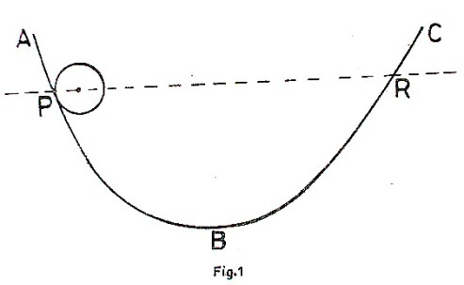

The diagram in the figure shows a large smooth bowl ABC. Explain what happens when a ball is released from P.

(b) Describe how you would measure the mass of a metre rule using a known mass and a knife edge only.

(c) In a pulley system, the distance moved by the effort is five (5) times the distance moved by a load. Calculate the efficiency if an effort just to move a load of 60N is 20N

2. (a) What is meant by conduction?

(b) Draw a diagram of a thermos flask and explain how it is able to keep a liquid cool for a long time.

(c) With the help of a labeled diagram, describe how you would determine the upper fixed point of an uncalibrated thermometer.

(d) Explain the following observations

(i) A bare cement floor feels colder than a carpeted one.

(ii) A beam with a notch; that is used for constricting a bridge, last longer when the notch is on its top surface than when the notch is on its lower surface.

3. (a) With the aid of a diagram, describe the effect of a shear force on a body.

(b) (i) What is meant by strength as applied on a material?

(ii) State the factors on which strength on a material depends.

(c) (i) Describe a simple experiment to describe Hooke’s law using a spring.

(ii) State any three characteristics of concrete which make it a desirable building material.

4. (a) (i) Describe how the speed of waves in a ripple tank can be increased.

(ii) Explain the effect of decreasing the speed of the wave in(a) (i) on frequency.

(b) With the aid of a sketch diagram, explain the effect of size of a gap on diffraction of waves.

(c ) (i) Give two reasons why sound is louder at night than during the day.

1. An echo sounding equipment on a ship receives sound pulses from the sea bed 0.02 after they were sent out from it. If the speed of sound in water is 1500ms-1, calculate the depth of water un der the ship.

(d) Identify two differences between water and sound waves.

5. (a) With the aid of diagrams, distinguish between diffuse and regular reflection

(b)

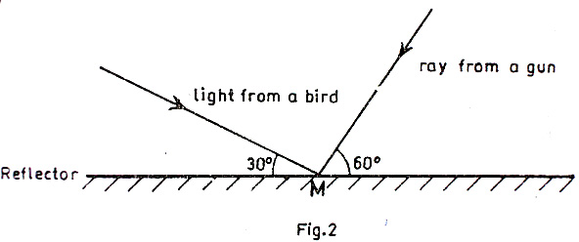

A ray from a bird makes an angle of 300 with a plane reflector and a ray from the barrel of a gun makes an angle of 600 to the same reflector at the same point, M as shown in the figure. Find the angle through which the reflector must be rotated about M such that the ray from the barrel of the gun falls on the bird.

(c) With the aid of the diagram explain why a parabolic mirror is most suitable for use in car head lights.

(d) List three uses of a concave mirror

6. (a) What happens when a magnet is

(i) Dipped in iron filings

(ii) Freely suspended in air

(b)

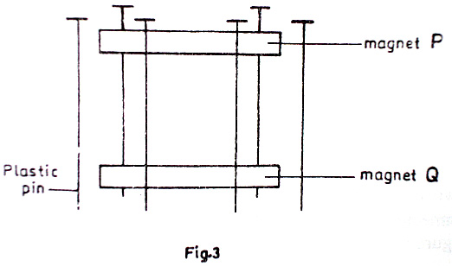

A powerful magnet Q is placed on a soft board. Plastic pins are firmly stuck in the soft board around the magnet. An identical magnet P, is held in the space surrounded by the pins above the magnet Q. When the magnet P is released, it floats above the magnet Q as shown in figure 3.

(i) Explain why P floats above Q.

(ii) Why are plastic pins used instead of steel pins.

(iii) What would happen to magnet P if all the pins were removed at the same time.

(c) Explain the terms of the domain theory how a steel bar gets magnetized by stroking.

7. (a) Draw sketch graphs of p.d., against current, I, for the following

(i) A wire

(ii) An electrolyte

(iii) A semi-conductor dioxide

(b) Explain the differences between the voltmeter and an ammeter in terms of their

(i) Construction

(ii) Use

(c) State three physical properties that affect the resistance of a solid conductor.

(d)

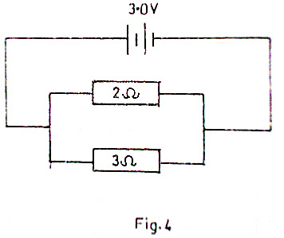

Two cells of each e.m.f. 1.5v and negligible internal resistance are connected in series across two resistors of 2Ω and 3Ω as shown in the figure 4. calculate the current

1. supplied by the cells.
2. that passes through the 3Ω resistor.

8. (a)

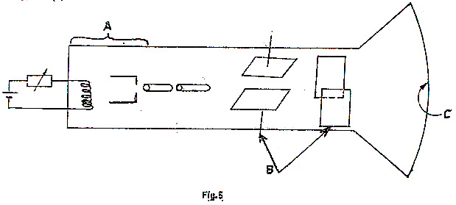

Tthe diagram in figure 5 shows the main parts of a cathode ray oscilloscope (C.R.O.)

1. name the parts labeled A, B and C.
2. Why is the C.R.O evacuated.

(b) (i) Describe briefly the principles of operation of C.R.O.

(ii) How is the bright spot formed on the screen?

(c) Use diagrams to show what is observed on the screen of a C.R.O. when

(i) The C.R.O. is switched on and no signal is applied on the Y-plates

(ii) The time-base is switched on and no signal is applied to the Y-plates.

(iii) An alternating signal is applied to the Y-plates while the time-base is switched off.

(d) Give two uses of C.R.O.

**END**

**\*\*\*\*\*\*\*\*\*\***

## Go to Index | [E-mail Designer](mailto:kecan44@mynet.com?subject=Comments%20about%20UCE%20Chemistry%201.0) |

|  |  |  |
| --- | --- | --- |
| **535/2**  **PHYSICS**  **PAPER 2** Nov./Dec. 20032 hours |  | UGANDA NATIONAL EXAMINATION BOARD  **Uganda Certificate of Education**  **PHYSICS**  **Paper 2**  **Time: 2 Hours** |

1. ( a) Define the following

(i) velocity

(ii) momentum

(b) A small iron ball dropped from a top of a vertical cliff takes 2.5 s to reach the bottom of the cliff. Find

(i) The speed with which it strikes the bottom

(ii) The height of the cliff.

(c) Explain why a person feels heavier than usual at the instant the lift starts accelerating upwards.

(d) A valve of a cylinder containing 12kg of compressed gas is opened and the cylinder empties in 90 seconds. If the gas flows out of the nozzle at an average speed of 25ms-1, find the average force exerted on the cylinders

2. (a) Define a joule?

(b) (i) What is meant by linear momentum?

(ii) State the law of conservation of linear momentum.

(c) A bullet of mass 20 g is fired onto a block of wood of mass 400 g lying on a smooth horizontal surface. If the bullet and the wood move together with the speed of 20 ms-1, calculate.

(i) The speed with which the bullet hits the wood,

(ii) The kinetic energy lost.

(d) State the energy changes involved in (c) above.

3. ( a) (i) What is meant by the term diffusion?

(ii) State factors on which diffusion depends.

( b) Describe an experiment to show diffusion in liquids.

(c) A porous pot containing air is connected to a water manometer. Explain what happens if hydrogen is let in the space surrounding the as shown in the figure.

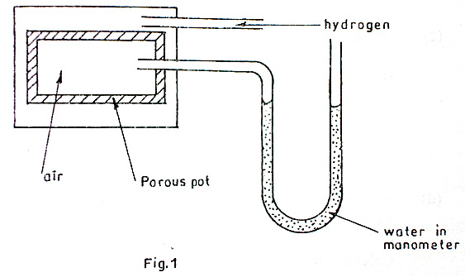

(d) (i) Describe a simple experiment to show surface tension in water.

(ii) State two factors which affect surface tension.

4. (a) What is an equation of state of a gas?

(b) (i) With the aid of a sketch graph, describe how absolute zero of temperature can be

defined.

(ii) Use the kinetic theory of gases to explain the existence of absolute zero of temperature.

(c) A volume of 2500 cm3 of hydrogen gas is collected at 670C at a pressure of 730 mmHg. Calculate the volume the gas at s.t.p.

(d) Smoke is confined in a smoke cell and observed through a microscope. Explain what is observed when the temperature of the smoke cell is raised.

5. ( a) What is meant by sound?

(b) Describe an experiment to show that sound waves require a material medium for transmission.

(c) Explain briefly the following:

(i) a dog is more able than a human being to detect the presence of a thief tip-toeing at night.

(ii) An approaching train can easily be detected by human ears placed close to the rails

(d) A sound of frequency 250Hz is produced 120m away from a high wall. Calculate the:

(i) wave-length,

(ii) Time it takes the sound wave to travel to and from the wall.

(Speed of sound in air = 330ms-2)

6. (a) With the aid of a diagram, explain, the use of keepers to store magnets.

(b) (i) Describe using a labeled diagram how a telephone receiver works.

(ii) State two ways by which the strength of an electro magnet can be increased.

(c) A bulb is rated 12.0volts, 36 watts when used on a 12.0 volts supply.

(i) How much current does it draw from the supply?

(ii) What is its resistance?

7. ( a) (i) Draw a labeled diagram of a lead acid accumulator.

(ii) List three precautions necessary to prolong the life of an accumulator.

(iii) State two disadvantages of a Nife cell over a lead acid cell.

( b) What is meant by the following.

1. Electromotive force,
2. Internal resistance of a cell.

(c) A cell is connected in series with an ammeter and a variable resistor. The potential difference, V, across the resistor varies with current I, supplied through the resistor as shown in the graph in the figure. Use the graph to determine the

(i) e.m.f

(ii) internal resistance of the cell.

8. (a) What is meant by the following.

1. thermonic emission
2. photo-electric effect?

(b) (i) State the conditions necessary for photo-electric effect to take place?

(ii) With aid of a labeled diagram, describe how an alternating current can be fully rectified.

(c) Explain how leakage of charge occurs at the ends of sharp conductors.

**END**

**\*\*\*\*\*\*\*\*\*\***

## Go to Index | [E-mail Designer](mailto:kecan44@mynet.com?subject=Comments%20about%20UCE%20Chemistry%201.0) |

|  |  |  |
| --- | --- | --- |
| **535/2**  **PHYSICS**  **PAPER 2** Nov./Dec. 20042 hours |  | UGANDA NATIONAL EXAMINATION BOARD  **Uganda Certificate of Education**  **PHYSICS**  **Paper 2**  **Time: 2 Hours** |

1. (a) Describe an experiment to estimate the thickness of an oil molecule

(b) Explain the following observations

(i) When mercury and water are separately poured on a glass, mercury does not wet the glass

(ii) When a detergent is added to a clean water surface, a needle floating on it (water surface) sinks

(c) A small ball is allowed to fall centrally down a small cylinder containing lubricating oil

(i) Sketch the velocity-time graph for the motion of the ball

(ii) Describe the features of the graph

2. (a) Define velocity-ratio as applied to machines

****

(b) The above graph shows how load varies with effort in an experiment using a single string pulley system of velocity-ratio 5. For a load of 450N, find the

(i) effort

(ii) mechanical advantage

(iii) efficiency

(c) A block and tackle pulley system has two pulleys in the lower block and three in the upper block. Sketch

(i) The diagram of this pulley system.

(ii) a graph showing variation of mechanical advantage with load.

(iii) explain why the efficiency of the pulley system is less than 100%.

(d) Name any two uses of the type of pulley system drawn in (c) (ii) above.

3. (a) Define specific latent heat of vaporization

(b) A calorimeter of mass 35.0 g and specific heat capacity 840 JKg-1K-1 contains 143.0 g of water at 70C. Dry steam at 100 0C is bubbled through the water in the calorimeter until the temperature of the water rises up to 29 0C. If the mass of the steam which condenses is 5.6 g,

(i) calculate the heat gained by the water and the calorimeter

(ii) obtain an expression for the heat lost by the steam in condensing at 100 0C and in cooling to 29 0C

(iii) find the specific latent heat of vaporization of water

4. (a) (i) What is a magnetic field?

(ii) State the law of magnetism

(b) (i) Explain with the aid of diagrams how a steel bar can be magnetised by single touch

method

(ii) Sketch the magnetic field pattern of two bar magnets whose north poles face each other

(c) With the aid of a labeled diagram, explain how a simple a.c generator works

5. (a) What is meant by conductor and insulator? Give an example of each

(b) (i) Explain briefly how you can charge a conductor negatively by induction

(ii) Describe how it can be confirmed that the conductor in (b) (i) is negatively charged

(c) Explain the action of a lightning conductor

6. (a) Explain dispersion as applied to light.

(i) What is a pure spectrum

(ii) With the aid of a labeled diagram, explain briefly how a pure spectrum is produced

(c) (i) Distinguish between a primary colour and secondary colour

(ii) The figure below shows colours mixed by addition. Name the colours represented by parts A, B, C and D.

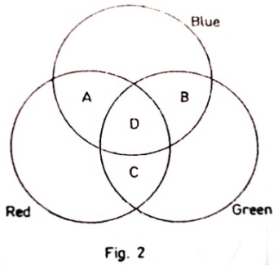

(d) State the colour of a yellow dress in green light.

7. (a) (i) Define an echo.

(ii) State the conditions required for a stationary wave to be formed.

(b) State three factors on which frequency of a wave in a vibrating string depends.

(c) Describe an experiment to demonstrate resonance in a closed pipe.

(d) A child stands between two cliffs and makes a loud sound. If he hears the first echo after 1.5 s and the second one after 2.0 s, find the distance between the two cliffs.

(Speed of sound in air is 320ms-1)

8. (a) (i) What is meant by cathode rays

(ii) With the aid of a diagram, describe how cathode rays are produced by thermionic effect?

(b) With reference to the cathode ray oscilloscope, describe;

(i) the function of the time base

(ii) how the brightness is regulated

(c) A cathode ray oscilloscope (C.R.O) with time-base switched on is connected across a power supply. The waveform shown in the figure below is obtained.

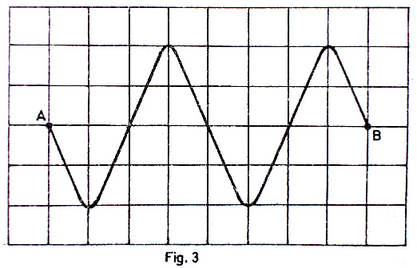

Distance between each line is 1cm.

1. Identify the type of voltage generated by the power supply
2. Find the amplitude of the voltage generated if the source of the time-base setting on the C.R.O is 5x10-3cm-1

**END**

**\*\*\*\*\*\*\*\*\*\***

## Go to Index | [E-mail Designer](mailto:kecan44@mynet.com?subject=Comments%20about%20UCE%20Chemistry%201.0) |

|  |  |  |
| --- | --- | --- |
| **535/2**  **PHYSICS**  **PAPER 2** Nov./Dec. 20052 ¼hours |  | UGANDA NATIONAL EXAMINATION BOARD  **Uganda Certificate of Education**  **PHYSICS**  **Paper 2**  **Time: 2 Hours 15 Minutes** |

**INS;** *Attempt any* **five** *questions,*

Mathematical tables, slide rules and silent non-programmable calculators may beused.

*These values of physical quantities may be useful to you.*

*Acceleration due to gravity =* 10ms2

*Specific heat capacity of water* =4200 J kg'1 K'1

*Specific heat capacity of^opnpr =* 400Jkg'lK:1

Specific latent heat of fusion of water = 3400001kg'1

Speed of sound in air = 320ms-1

**INSTRUCTIONS ;** *Attempt all**questions,*

Mathematical tables, slide rules and silent non-programmable calculators may beused.

*These values of physical quantities may be useful to you.*

*Acceleration due to gravity =* 10ms2

*Specific heat capacity of water* =4200 J kg'1 K'1

*Specific heat capacity of^opnpr =* 400Jkg'lK:1

Specific latent heat of fusion of water = 3400001kg'1

Speed of sound in air = 320ms-1

**2005 paper 2**

1. (a) State **Hooke's law of elasticity.** *(01 mark)*

(b) Different loads, w, are applied to the end of an elastic

wire and the corresponding extension, e, of the wire recorded,

(i) Sketch a labelled graph of e against w. *(03 marks)*

*(ii)* Describe briefly the features of the graph in (b)

(i), *(02 marks)*

*(c)* A spring of natural length 5.0 x 10"2 m extends by

2.0 x 103 m when a force of 1.8 N acts on it.

Calculate the extension when a force of 10 N is applied to the spring. *(06 marks)*

(d) Describe an experiment to demonstrate the existence of

surface tension. *(04 marks)*

2, (a) (i) Describe the fixed points of a Celsius scale of temperature. *(02 marks)*

(ii) Give two advantages of mercury over alcohol as a thermometric liquid. (*02 marks)*

(iii) Convert -200°C to Kelvins,

(b) Use the kinetic theory to explain the following:

(i) cooling by evaporation. *(01 mark)*

*(05 marks)*

(ii) why the temperature of a gas contained in a cylinder increases when it is compressed. *(03 marks)*

*(c)* Explain briefly the transfer of thermal energy by conduction in metals. *(03 marks)*

*3.*

|  |  |
| --- | --- |
| N | •1 |

**coil**

(a) A cable is connected to a centre-zero galvanometer, G, as

sftown in Figure 1.

(i) State what is observed when the N-pole of a bar

magnet is moved towards the cable *(01 mark)*

(ii) State two ways in which the effect observed in (a) (i) can be increased. *(02 marks)*

(b) (i) With the aid of a labelled diagram describe how a simple a,c. generator works. (05 *marks)*

*(ii)* Sketch the variation of the voltage from an ax.

generator and use it to define the terms peak value and period. *(04 mark?)*

(c) With the aid of a labelled diagram, describe how full wave rectification can be obtained using four diodes. *(04 marks)*

4 (a) Describe how you would use a gold leaf electroscope to

determine the sign of the charge on a given charged body. *(05 marks)*

(b) Explain how an insulator gets charged by rubbing. *(03 marks)*

*(c)* Sketch the electric field pattern between a charged point and a metal plate. *(02 marks)*

*(d)* Describe how a lightning conductor safeguards a tall

building from being struck by lightning. (06 coarks)

5. (a) (i) State the principle of conservation of energy. *(01 mark)*

*(ii)* Illustrate die principle in (a) (i) with reference to a simple pendulum in a vacuum. *(04 marks)*

(b) A ball of mass 030 kg falls from rest at a height of 4.0 m onto a her ,*al surface and rebounds to a height of 2.0 m.

(i) Find the kinetic energy just before the ball hits the surf ace; and just after the collision. Explain the difference between the two energies. *(06 marks)*

(ii) What is its initial momentum? *(05 marks)*

**Tig. 1**

6. (a) State any two differences between sound and light waves. *(02 mark*«

(b) (i) Descnbe a simple experiment to determine the velocity of sound in air, *(04 marl,*

(ii) Explain why the speed of sound is higher in solids than in air. *(03 mar'^*

(c) Two people X and Y stand in a line at distances of 330 m and 660 m respectively from a high wail. Find the time interval taken for X to hear the first and second sounds when Y makes a loud sound. (Speed of sound in air = 330ms"1) *(03 marh.*

(d) (i) What is meant by a stationary wave? (*01 mar}.*

(ii) Give any two conditions.  *(02 marh*

(iii) Name one musical instrument which produces stationary waves. *(01*

7. (a) Explain with aid of a ray diagram, the formation of umbra and penumbra. *(06mar>^*

(b) Draw a ray diagram to show the action of a converging lens as a magnifying glass. *(02 marb*

(c) (i) State any three effects of electromagnetic radiation on matter *(03 marl-.*

(ii) State two properties that electromagnetic waves have in common, *(02 mark*

(d) A radio wave of wavelength 330 m is transmitted at a frequency of 90S kHz. Find its velocity. (03 *marti*

8. (a) Draw a labelled diagram to show the main bands of the electromagnetic spectrum. *(03 marh-*

(b) (i) With the aid of a labelled diagram, describe how x-rays are produced in an x-ray

tube. *(08 mar\**

(c) State two applications of x-rays. *(02 mark:-*

The half life of a radioactive substance is 3 h. Find how long it take.* for the mass of the substance to reduce to one-quarter of its original mass. *(03 marh]*

## Go to Index | [E-mail Designer](mailto:kecan44@mynet.com?subject=Comments%20about%20UCE%20Chemistry%201.0) |

|  |  |  |
| --- | --- | --- |
| **535/2**  **PHYSICS**  **PAPER 2** Nov./Dec. 20062 hours |  | UGANDA NATIONAL EXAMINATION BOARD  **Uganda Certificate of Education**  **PHYSICS**  **Paper 2**  **Time: 2 Hours** |

1. (a) State **Newton’s laws of motion**. (03marks)

(b) A block of mass 50kg is pulled from rest along a horizontal surface by a rope tied to one of

the block as shown in Figure 1.

The tension in the rope is 220N. the frictional force between the block and the horizontal surface is 120N.

1. Find the acceleration of the block. (03marks)

(ii) Calculate the distance moved by the block in 4.0s. (02marks)

(iii) What is the reaction of the surface on the block. (02marks)

1. Compare the work done by the tension in the rope during the 4.0s interval with

kinetic energy gained. (06marks)

2. (a) What is meant by **pressure**? (01mark)

(b) (i) Explain why one feels more pain when pricked with a needle than when pricked with

a nail. (05marks)

(ii) State the **assumption made**. (01mark)

(c) With the aid of a labeled diagram, explain how a force pump works. (06marks)

(d) Calculate the pressure exerted on the ground by a box of mass 10kg when corresponding

area of contact is 2m2. (03marks)

3. (a) Distinguish between **angle of dip (inclination)** and **angle of declination.** (03marks)

(b) Draw a diagram to show the magnetic pattern around a bar of magnet placed in the earth’s

field with the north pole of the magnet pointing to the earth’s magnetic south. (03marks)

(c) (i) What is an **electromagnet**? (01mark)

(ii) Describe with aid of a labeled diagram how an electric bell works

(d)

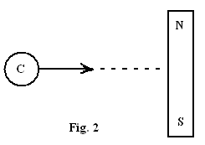

Describe what happens to the compass needle, **C**, as it is moved closer to the bar magnet along the dotted line shown in Figure 2. (03marks)

4. (a) Define the following terms:

(i) the volt, (01mark)

(ii) electrical resistance. (01mark)

(b) List ways by which the life of an accumulator can be prolonged. (03marks)

(c)

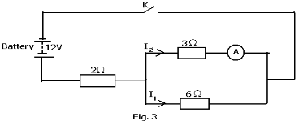

A battery of e.m.f 12V and negligible internal resistance is connected to resistances 2, 3 and 6 as shown in Figure 3. Find the reading of the ammeter, **A**, when **K** is closed.

(07marks)

(d) State **three** advantages of an alternating current over a direct current in power transmission.

(03marks)

(e) Sketch the current versus voltage variation for a semi conductor diode. (01mark)

5. (a) Define the following terms as applied to waves:

(i) **amplitude**, (01mark)

(ii) **frequency.** (01mark)

(b) (i) What is meant by **interference of waves**? (02marks)

(ii) Using a labeled diagram, show how circular water waves are reflected from a straight

barrier. (03marks)

(c) (i) Use a labeled diagram to show the bands of electromagnetic spectrum. (03marks)

(d) With the aid of a diagram, show dispersion of light by a prism. (03marks)

6. (a) (i) Distinguish between **nuclear fusion** and **nuclear fission**. (02marks)

(ii) State **one** example where nuclear fusion occurs naturally. (01mark)

(b) State **one** use of nuclear fission. (01mark)

(c) The following nuclear reaction takes place when a neutron bombards a sulphur atom.

+ →

(i) Describe the composition of the nuclide, Y, formed. (02marks)

(ii) The nuclide, Y, decays by emission of an -particle and a -ray. Find the changes

in mass and atomic number of the nuclide. (02marks)

(iii) State **two** properties of -particle. (02marks)

(d) The half-life of the isotope cobalt-60 is **five** years. What fraction of the isotope remains after

15 years? (03marks)

(e) State:

(i) **one** medical use of radioisotopes. (01mark)

(ii) **two** ways of minimizing the hazardous effects of radiation from radioactive

materials. (02marks)

7. (a) Explain the term **virtual image** as applied to optics. (03marks)

(b) With aid of a ray diagram, explain why a convex mirror is used as a driving mirror.

(05marks)

(c) An object is placed 15.0cm in front of a concave mirror. An upright image of magnification

**four** is produced. By graphical method, determine the:

(i) nature of the image

(ii) focal length of the mirror.

(iii) distance of the image from the mirror. (06marks)

(d) Name **two** applications of a concave mirror. (02marks)

8. (a) (i) Define **latent heat of fusion**. (01mark)

(ii) Describe with aid of a labelled diagram, an experiment to show the effect of increase

in pressure on the melting point of ice. (04marks)

(iii) If the melting point of lead is 3270C, find the amount of heat required to melt 200g of

lead initially at 270C. (04marks)

Specific heat capacity of lead is 140JKg-1K-1, Specific latent heat of fusion of lead is 2.7105JKg-1

(b) What is meant by the terms:

(i) **temperature**,

(ii) **heat**? (02marks)

1. The fundamental interval of mercury in glass is 192mm. Find the temperature in degrees Celsius when the mercury thread is 67.2mm long. (03marks)
2. State **two** physical properties which change with temperature. (02marks)

**END**

**\*\*\*\*\*\*\*\*\*\***

## Go to Index | [E-mail Designer](mailto:kecan44@mynet.com?subject=Comments%20about%20UCE%20Chemistry%201.0) |

|  |  |  |
| --- | --- | --- |
| **535/2**  **PHYSICS**  **PAPER 2** Nov./Dec. 20072 hours |  | UGANDA NATIONAL EXAMINATION BOARD  **Uganda Certificate of Education**  **PHYSICS**  **Paper 2**  **Time: 2 Hours** |

1. (a) What is meant by

(i) velocity ratio of a machine? (01mark)

(ii) pitch of a screw? (01mark)

1. A screw jack with a lever arm of 56cm and a pitch of 2.5mm is used to raise a load of 800N,

if its efficiency is 25%, find

(i) the velocity ratio. (04marks)

(ii) mechanical advantage. (03marks)

(c) Describe an experiment to show how the mechanical advantage of a block and tackle pulley system with velocity ratio 4 varies with the load. (07marks)

2. (a) What is the **absolute zero of temperature**? (01mark)

( b) Explain, using the kinetic theory, why the pressure of air inside a car tyre increases on a hot day. (03marks)

(c) Describe with the aid of a labeled diagram an experiment to investigate the effect of temperature on the volume of a fixed mass of gas at constant pressure. (08marks)

(d) The same quantity of heat was supplied to 5.0 kg of sea water and 12.0kg of methylated spirit. The temperature rise was 3.00C and 2.00C respectively. Find the ratio of the specific heat capacity of sea water to that of methylated spirit. (04marks)

3. (a) (i) Explain what is meant by polarization as applied to a simple cell. (03marks)

(ii) State how polarization can be minimized in a simple cell. (01mark)

(b) Explain how the life of a lead-acid accumulator may be prolonged. (06marks)

(c)

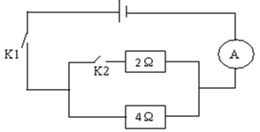

What will be the reading of the ammeter in figure 1 if switch K2 is

(i) open and K1 closed? (02marks)

(ii) closed and K1 closed? (04marks)

4. (a) State the **laws of reflection**. (02marks)

(b) Describe a simple experiment to demonstrate the principle of reversibility of light. (05marks)

(c) An object is released from a height of 10m above a plane mirror. What distance must it drop

through in order to be 5m away from its image. (02marks)

(d)

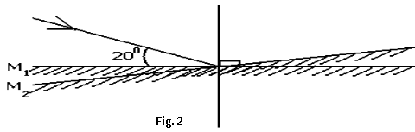

An incident ray makes an angle of 200 with the plane mirror in position M1, as show in Figure 2. What will be the angle of reflection, if the mirror is rotated through 60 to position M2 while direction of the incident ray remains the same? (03marks)

(d) With the aid of a ray diagram, explain how a thick plane mirror forms multiple images of an

object. (04marks)

5. (a) (i) Define **moment of a force**. (01mark)

(ii) State the **principle of moments**. (01mark)

(b) Describe an experiment to determine the mass of an object using a metre rule and a single

known mass. (07marks)

(c)

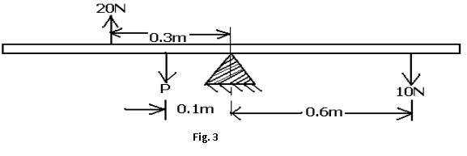

Forces of 20N, 10N and **P** act on a uniform rod pivoted at its centre as shown in Figure 3. find the magnitude of **P** if the system is in equilibrium. (03marks)

(d) (i) State **two** applications of the principle of moments. (02marks)

(ii) Draw a diagram to show the forces acting on an object resting on a table. (01mark)

6. (a) Define the term **constructive interference** as applied to sound waves. (01mark)

(b)

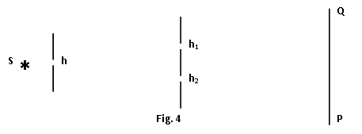

Figure 4 shows a source of sound S behind a barrier with a single hole h, place behind another barrier with two identical holes h1 and h2. A sound detector is moved along a line **PQ**. (i) With the aid of a diagram explain what is detected. (05marks)

(ii) What is the significance of h1 and h2? (02marks)

(c)

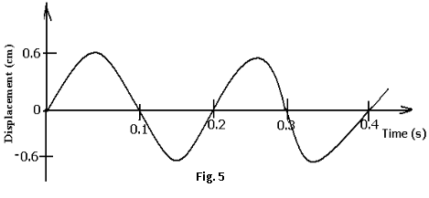

Figure 5 shows the displacement-time graph of a wave traveling through water with a velocity of 2.5mms-1. Find the

(i) amplitude (01mark)

(ii) period (01mark)

(iii) wavelength of the wave. (03marks)

(b) What are the conditions for formation of a standing wave with the wave in (c) above? (03marks)

7. (a) What is meant by a **magnetic field**? (01mark)

(b) Explain with the aid of a diagram what happens when two vertical, parallel conductors are near one another and carry current in

(i) the same direction. (03marks)

(ii) opposite direction. (03marks)

(c) (i) Describe with the aid of a diagram, how a direct current generator works. (06marks)

(ii) State **three** ways of increasing the e.m.f produced by the generator. (03marks)

8. ( a) What are **X-rays**? (01mark)

(b) With the aid of a labeled diagram, describe the structure and operation of an X-ray tube.

(08marks)

( c) Explain briefly how each of the following can be increased in an X-ray tube:

(i) intensity of X-rays. (02marks)

(ii) penetrating power of X-rays. (02marks)

(d) State **four** ways in which X-rays are similar to gamma rays. (02marks)

( e) Give **two** biological uses of X-rays. (02marks)

**END**

**\*\*\*\*\*\*\*\*\*\***

## Go to Index | [E-mail Designer](mailto:kecan44@mynet.com?subject=Comments%20about%20UCE%20Chemistry%201.0) |

|  |  |  |
| --- | --- | --- |
| **535/2**  **PHYSICS**  **PAPER 2** Nov./Dec. 20082 hours |  | UGANDA NATIONAL EXAMINATION BOARD  **Uganda Certificate of Education**  **PHYSICS**  **Paper 2**  **Time: 2 Hours** |

1. (a) Group the following quantities into scalars and vectors; Temperature, momentum, time

and acceleration. *(02 marks)*

(b) The graph in fig. 1 represents variation of velocity with Time of two athletes A and B.

|  |  |  |  |  |  |  |  |  |  |  |  |  |  |  |  |  |  |  |  |  |  |  |  |  |  |  |  |  |  |  |  |  |  |  |  |  |  |  |  |  |  |  |  |  |  |  |  |  |  |  |  |  |  |  |  |
| --- | --- | --- | --- | --- | --- | --- | --- | --- | --- | --- | --- | --- | --- | --- | --- | --- | --- | --- | --- | --- | --- | --- | --- | --- | --- | --- | --- | --- | --- | --- | --- | --- | --- | --- | --- | --- | --- | --- | --- | --- | --- | --- | --- | --- | --- | --- | --- | --- | --- | --- | --- | --- | --- | --- | --- |
| (b)  **v/ms-1**   |  |  |  |  |  |  |  | | --- | --- | --- | --- | --- | --- | --- | | **16**  **14**  **12**  **10**  **8**  **6**  **4**  **2** |  |  |  |  |  |  | |  |  |  |  |  |  | |  |  |  |  |  |  | |  |  |  |  | A |  | |  |  |  |  |  |  | |  |  |  |  |  |  | |  |  |  |  | B |  | |  |  |  |  |  |  | | **10 20 30 40 50 T/s** | | | | | | |

(c) A stone of mass 100 g is thrown vertically upwards with a force 5 N. What is its initial acceleration? (g = 10 ms-1). *(04 marks)*

(d) Describe what happens when air is blown into a balloon and the balloon released. *(02 marks)*

2. (a) Distinguish between specific heat capacity and heat capacity. *(02 marks)*

(b) Explain how a hot object standing on a metallic table on the surface of the moon loses heat.

*(04 marks)*

(c) Outline the steps and precautions needed in measuring the specific heat capacity of a liquid by method of mixtures. *(07 marks)*

(d) The 0 °C and 100 °C marks on a liquid- in-glass thermometer are 10 cm apart. What would be the temperature if the liquid fell 2 cm below the 0 C mark? *(03 marks)*

3. (a) Define the following terms as applied to magnetism:

1. Ferromagnetic material. *(01 mark)*
2. Neutral point. *(01 mark)*

(b) Sketch the magnetic field pattern around a

(i) bar magnet whose axis lies along the magnetic north. *(01 mark)*

(ii) circular current carrying coil. *(01 mark)*

(c) With the aid of a labelled diagram, explain how an electric bell works. *(07 marks)*

(d) (i) What is meant by a magnetically saturated material?  *(02 marks)*

(ii) State one method of magnetizing a magnet. *(01 mark)*

4. A student set up the circuit in Fig. 2 to determine the maximum current which can be taken by a fuse wire.

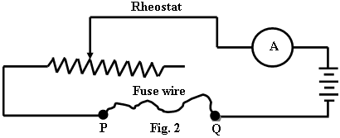

(a) Describe briefly how this circuit could be used to determine the maximum current.

*(03 marks)*

(b) Explain what would happen if

(i) two strands of the wire fuse were connected in parallel across P and Q. *(03 marks)*

(ii) the length of the fuse wire were doubled. *(03 marks)*

(c) An electric fire, a amp and electric drill rated at 200 W, 100 W and W respectively are connected in parallel across a 240 V mains.

Find the

(i) power taken from the mains. *(01 mark)*

(ii) current supplied by the mains. *(03 marks)*

(iii) cost of running these appliances for 12 h if one unit costs Shs. 200. *(03 marks)*

5. (a) Define density and state its SI unit. *(02 marks)*

(b) With the aid of a labelled diagram, describe the motion of a ball bearing which is dropped centrallyinto a tall jar containing oil.  *(04 marks)*

(d) Explain why a ship is able to float on water in spite of being made of metal. *(01 mark)*

6. (a) State the changes detected when listening to a sound note if the

(i) amplitude is raised. *(01 mark)*

(ii) frequency is increased. *(01 mark)*

(b) Give three differences between light waves and sound waves. *(01 mark)*

(c)

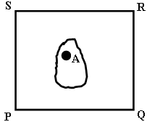

Fig. 3

Figure 3 shows a ripple tank PQRS whose one side is raised. A ripple started by touching the water at A, and after one second it ad the shape shown.

1. State which side of the tank is raised. *(01 mark)*
2. Explain the shape of the ripple. *(04 marks)*

(d)

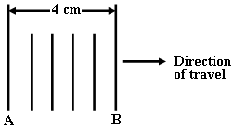

Fig. 4

The lines in fig. 4 show crests of straight ripples formed in a ripple tank.

1. If after 10 seconds A is in position B, calculate the velocity of the ripples. *(04 marks)*
2. Draw a diagram showing how the ripples would pass through a wide gap of an obstacle they would meet. *(02 marks)*

7. (a) What is meant by a **light ray**? *(01 mark)*

(b) With the aid of a labelled diagram, describe the structure and working of a simple lens camera. *(06 marks)*

(c) State two differences between the human eye and the lens camera. *(02 marks)*

(d) (i) State the **laws of refraction**. *(02 marks)*

(ii)

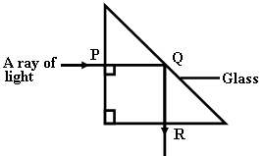

**Fig. 5**

Figure 5 shows a ray of light incident on a right angled prism of refractive index 1.5. Explain why the ray of light follows the path shown. *(05 marks)*

8. (a) (i) What are **cathode rays**? *(01 mark)*

(ii) State two differences between gamma rays and cathode rays. *(02 marks)*

(b) Describe a simple experiment to distinguish the three radiations that are emitted by radioactive materials. *(04 marks)*

(c) A radioactive element has a half life of 4 minutes. Given that the original count rate is 256 counts per minute,

1. Find the time taken to reach a count rate of 16 counts per minute. *(02 marks)*
2. What fraction of the original number of atoms will be left by the time the count rate is 16 counts per minute. *(01 marks)*

(d) (i) Which of the following nuclei belongs to the same element:

, , ? *(02 marks)*

(ii) What is **nuclear fusion**? *(02 marks)*

**END**

**\*\*\*\*\*\*\*\*\*\***

## Go to Index | [E-mail Designer](mailto:kecan44@mynet.com?subject=Comments%20about%20UCE%20Chemistry%201.0) |

|  |  |  |
| --- | --- | --- |
| **535/2**  **PHYSICS**  **PAPER 2** Nov./Dec. 20092 hours |  | UGANDA NATIONAL EXAMINATION BOARD  **Uganda Certificate of Education**  **PHYSICS**  **Paper 2**  **Time: 2 Hours** |

**INSTRUCTIONS TO CANDIDATES**

Answer any five questions.

Mathematical tables and silent non-programmable calculators may be used.

These values of physical quantities may be useful to you.

|  |  |  |
| --- | --- | --- |
| Acceleration due to gravity | = | 10 m s-2 |
| Specific heat capacity of water | = | 4200 J Kg-1 K-1 |
| Specific heat capacity of Copper | = | 400 J Kg-1 K-1 |
| Specific latent heat of fusion of water | = | 340000 J Kg-1 |
| Speed of sound in air | = | 320 m s-1 |
| Velocity of electromagnetic waves | = | 3.0 x 108 m s -1 |

1. (a) State the

(i) law of conservation of momentum.

(ii) factors on which linear momentum depends.

(b) Explain what happens when a balloon is filled with air and then released in space without tying its open end.

(c) Explain what happens to a passenger in a bus, when the driver brakes suddenly.

(d) Define the following terms:

(i) Displacement.

(ii) Force

(e) With the aid of a labeled diagram, describe an experiment to measure a uniform velocity of a body using a ticker timer.

2. (a) Define **momentum of a force.**

(b) Describe an experiment to determine the mass of a uniform metre rule using the principle of moments.

(c) 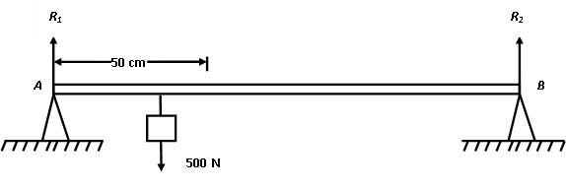

Figure **1** shows a uniform pole *AB* of length 2m and weight 50N supported at the ends *A* and *B*. A load of weight 500N is suspended at a point 50 cm from *A*.

Calculate the reaction forces *R1* and *R2* at the supports.

(d) (i) Explain what is meant by unstable equilibrium.

(ii) State **two** ways of increasing the stability of a body.

3. (a) Define the following terms;

(i) Strain

(ii) Tensile force

(b) With the aid of a diagram, explain the experiment to verify Hooke’s law using a spring.

(c) Explain why tea cups are usually made of clay materials and not metals.

(d) (i) A material of mass 2 kg requires 4.4 x 103 J for its temperature

to change from 60◦C to 80◦C. Calculate its specific heat capacity.

(ii) If the material in (d)(i) is placed in a vacuum, state why it cools.

4. (a) Describe with the aid of a labeled diagram the operation of a transformer.

(b) A 240 V step-down transformer mains transformer is designed to light **ten** 12 V, 20 W ray box lamps and draws a current of 1A in the primary coil.

Calculate the:

(i) power supplied to the primary coil.

(ii) power developed in the secondary coil.

(iii) efficiency of the transformer.

(c) With the aid of suitable diagrams, distinguish between an alternating current and a

direct current.

(d) Explain how a fuse as a safety device achieves its function in house wiring.

5. (a) Distinguish between thermionic emission and photoelectric emission.

(b)

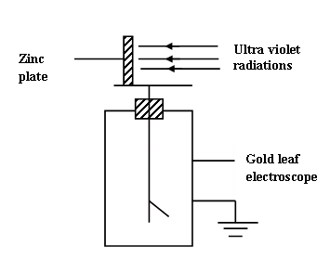

Ultra violet radiation is incident on a clean zinc plate on the cap of a charged gold leaf electroscope as shown in figure **2**. Explain what is observed if:

(i) the gold leaf electroscope is positively charged.

(ii) radio waves is used instead of ultra violet radiations.

(c) (i) With the aid of a labeled diagram, describe how *X*-rays are produced in an

*X*-ray tube.

(ii) Explain why soft X-rays are used instead of hard X-rays to take photographs of internal parts of a patient in hospitals.

6. (a) Define the term:

(i) amplitude.

(ii) wavelength.

(b) Draw diagrams to show how circular water ripples are reflected from;

(i) concave reflector.

(ii) convex reflector

(c) (i) Distinguish between longitudinal waves and transverse waves.

(ii) Give **one** example of each of the waves in (c) (i).

(d) State **four** properties of electromagnetic waves.

(e) The distance between two successive antinodes on a standing wave is 3.0 cm. If the distance between the source of wave and reflector is 24.0cm, find the

(i) number of loops.

(ii) wavelength of the wave.

7. (a) Define the following terms as applied to curved mirrors:

(i) Center of curvature.

(ii) Principal axis.

(b) Explain with the aid of ray diagrams, why a parabolic mirror is preferred to a concave mirror as a car head lamp.

(c) An object of height 5 cm is placed 15 cm in front of a concave mirror of radius of curvature 20cm. By scale drawing, find the

(i) image distance from the mirror.

(ii) height of the image.

(d) (i) With the aid of ray diagrams explain how regular and diffuse reflections

are produced.

(ii) State the characteristics of images formed in plane mirrors.

8. (a) What is meant by

(i) radioactivity?

(ii) half life?

(b) What happens to the activity of radioactive material when its

(i) mass is increased?

(ii) temperature is increased?

(c) A material is wrapped in a photographic film and kept in a dark room. When the photographic film is removed, it is found to be darkened.

(i) Identify the material.

(ii) Explain the observation.

(d) A radioactive substance of mass 60 g takes 400 years for its mass to be reduced to 15g. Find its half life.

(e) State:

(i) **two** industrial and **two** medical uses of radioactivity.

(ii) **two** health hazards of radioactivity.

**END**

## Go to Index | [E-mail Designer](mailto:kecan44@mynet.com?subject=Comments%20about%20UCE%20Chemistry%201.0) |

|  |  |  |
| --- | --- | --- |
| **535/2**  **PHYSICS**  **PAPER 2** Nov./Dec. 20102 hours |  | UGANDA NATIONAL EXAMINATION BOARD  **Uganda Certificate of Education**  **PHYSICS**  **Paper 2**  **Time: 2 Hours** |

## Go to Index | [E-mail Designer](mailto:kecan44@mynet.com?subject=Comments%20about%20UCE%20Chemistry%201.0) |

|  |  |  |
| --- | --- | --- |
| **535/2**  **PHYSICS**  **PAPER 2** Nov./Dec. 20112 hours |  | UGANDA NATIONAL EXAMINATION BOARD  **Uganda Certificate of Education**  **PHYSICS**  **Paper 2**  **Time: 2 Hours** |

## Go to Index | [E-mail Designer](mailto:kecan44@mynet.com?subject=Comments%20about%20UCE%20Chemistry%201.0) |

|  |  |  |
| --- | --- | --- |
| **535/2**  **PHYSICS**  **PAPER 2** Nov./Dec. 20122 hours |  | UGANDA NATIONAL EXAMINATION BOARD  **Uganda Certificate of Education**  **PHYSICS**  **Paper 2**  **Time: 2 Hours** |

Go to Index | [E-mail Designer](mailto:kecan44@mynet.com?subject=Comments%20about%20UCE%20Chemistry%201.0) |

|  |  |  |
| --- | --- | --- |
| FAQ’s |  | POSSIBLE PROBLEMS MAY BE FACED |

**PLEASE SEND US YOUR COMMENTS AND QUESTIONS.** [**swaibj@yahoo.com**](mailto:swaibj@yahoo.com)